CHAPTER I
INTRODUCTION
Overview and Background
Umbrella is a folding canopy that is supported with either wooden or metal rib. It is usually used for protection from direct exposure to the extreme sunlight and protection from rain. The Chinese invented the first waterproof umbrella as protection from rain when they waxed and lacquered paper parasol. Umbrellas became a feminine accessory beginning in the 16th century in Europe. In history, the first umbrellas didn’t shield people from rain, though. Instead, ancient people used them to block the sun. Umbrellas were used in ancient Egypt, Mesopotamia, China, and India. According to Merriam Webster the word ‘umbrella’ was borrowed from the Italian word ‘ombrella’ a modification of the Latin ‘umbrella’ which came from ‘umbra’, meaning shade or shadow. https: thecottonlondon.com/history-and -types-of-umbrella www.
Unquestionably, time goes by, humanities and technology has evolved as their needs and wants adopt their existence and niches. And born out of a dream to bring the ancient, flawed umbrella design into the 21st Century. KAZbrella is the only umbrella in the world that turns its frame. Which signifies that technology is a connection made to prosper infinitely the same thing with humanities for as long as the curiosity to improvised and provide exists. Which massively relates to the weather conditions such rainy season and summer season. https://kazbrella.com/en-ph/pages-umbrella-reinvented
In using umbrella, two or three persons can fit depending on their sizes. Students, workers, household etc. can use this item wherever they wanted to go. It is easy to carry however, it becomes a problem since for almost user are misplacing the item. In buying or purchasing an umbrella, we must need to see its build up and durability, such as quality of the product and the lifespan of the umbrella. Sometimes when using an umbrella for some reason and sometimes we forgot where we last used it and in instance worst, we lost it.
The study focuses on a prototype making of a smart umbrella using fingerprint security wherein, the owner will register their fingerprint to the umbrella itself. The owner will use its fingerprint to use the umbrella and it will automatically open from being folded. In some case that the user is busy or in a hurry and they left their umbrella anywhere. In this reason, the installed GPS module will be use so that the user can know where is the present location of the umbrella and where he/she left it last time and if ever it was stolen with someone else it would be useless for them to use it because the finger print has a strong security that only the registered fingerprint of the user has an access to open this smart umbrella. The Smart Umbrella is a Solar Energy operated via solar panels wherein it conserves solar power instead of consuming electricity. In case of emergency, Smart Umbrella can also provide power to charge gadgets such phones and etc.
Statement of the Problem
Carrying an umbrella. is necessary to everyone for the protection in direct exposure of sunlight and to the Unpredictable weather when attending schools, works, or going in someplace. However, at some point people tend to forget their Umbrellas and sometimes owners can’t identify the user or barrower of their umbrella. The researcher innovates a product to provide an umbrella security, to identify and minimize the user and easy to find in case of misplacing.
Objectives of the Study
General objectives
The main objectives of this study are to develop an anti-theft umbrella with fashionable design that will give new experience and vibe for the users.
Specific Objectives
This study specifically aims to;
- Design smart umbrella that has the ability to capture the solar energy for the operation of its system.
- Develop a smart umbrella that has finger print sensor that will either command the umbrella to open or close.
- Develop an application, where the user can register and monitor the functions of smart umbrella.
- Develop a security application to identify the user and eliminate the un-authorized user.
- Provide a data that would enable the registered user to locate the smart umbrella in case of misplacement using GPS
Significance of the Study
This study aims to build a smart umbrella via finger print and GPS controlled to help the user protect their property with security to found the item in case it was lost. It is also a chargeable type that would permit the user to get an extra rechargeable battery wherever they need it. This smart umbrella is a user friendly and can conserve energy.
The following are the contribution of smart umbrella:
User- it will alleviate the users’ experiences in smart umbrella functions specifically using its capacity to locate through the use of the android application.
Society- adopt or enhance the evolution of technology and live as an easy life experience as a 21st Century citizen.
Economics- they can enhance economic growth and efficiency by improving decision -making through the analysis of large amount of data, leading to the creation of new product.
Environment- it is environment friendly, smart umbrella is it not only for the protection on intense heat of sun, user also can save solar energy for smart umbrella operation supply
Scope and Delimitation
The smart Umbrella is a design that will benefit the owner for securing their property, the lifespan of this can vary depends upon the user’s maintainability. As for the security it provides, this helps the user trace their stuff using GPS. This is also sunlight dependent to store energy that would be used in charging the phone, flashlight and other necessary stuff that the user usually carries because it is solar type.
This study is conducted to several group of students in college of engineering at DR. EMELIO B. ESPINOSA SR. MEMORIAL STATE COLLEGE OF AGRICULTURE AND TECHNOLOGY. The smart umbrella offers numerous benefits, it also has certain limitations that need to be considered:
User Identification: the smart umbrella will use fingerprint authentication to identify authorized user. Only registered fingerprint will be accepted for unlocking and using the umbrella
Maximum number of users: The smart umbrella system can only support up to 27 registered users. Smart umbrella user’s login intended to data online verification for every registered user. Folding process: the folding process of smart umbrella is required manual operation.
Limited battery capacity: the size of the battery in a smart umbrella is typically small to keep the umbrella comfortable and lightweight. The amount of energy can be stored is limited.
Definition of Terms
The following are the components used in the study in which terms are defined in accordance with their functions in the study conducted.
Smart umbrella: A smart umbrella refers to an umbrella that incorporates advances technology and features to provide enhanced functionality, convenience, and user experience. It goes beyond the traditional purpose of shielding users from ran and sun by integrating various electronic components and intelligent features.
Microcontroller: Microcontroller refers to a small, integrated circuit that act as the brain or central processing unit of the umbrella electronic system. it is responsible for controlling and coordinating the various functions and features of the smart umbrella
DEBESMSCAT: Stands for Dr. Emilio B. Espinosa Sr. State College of Agriculture and Technology. it is an educational institution located at Cabitan, Mandaon, Masbate, Philippines, where the study was conducted.
Finger Print Reader: refers to a type of user security function that incorporates the concepts of an umbrella closed and open.
GPS Module - the used GPS Module that is used for tracking, measuring, and computing the location of the device or system that is needed to be tracked.
Wi-Fi module: refers to a hardware component that is enables wireless connectivity between umbrella and android device.
LCD Display: it is for output display
Actuator: it is used to control the opening and closing mechanism of umbrella through push button interface.
Solar panel: used to captures sunlight and convert it into electrical energy as a power source of umbrella to enhance the functionality and sustainability.
3.5v rechargeable battery: it is an electricity storage from sunlight captured that will be used when the sunlight is available for charging capacity it charge devices.
USB port: smart umbrellas may also include built-in charging ports, allowing users to charge their devices on the go, such as smartphones or tablets. This feature is especially useful during long walks or commutes in inclement weather.
5v channel relay: is an automatic switch that used in an automatic control circuit and to control high-current using a low-current signal.
Busser: Sound remind to users indicated every type of execution to components action.

CHAPTER II
Review of Related Literature
The following are the related study and literature of smart umbrella.
Related studies
Umbrella
The past century Going back as far as 3500 BCE, these umbrellas had poles made of bamboo sticks and animal skins stretched across them. the word ‘umbrella’ even came from. The word ‘umbrella’ is English. It derives from the Latin word ‘umbra’ which means ‘shadow’ or ‘shade. This tool was provided protection from both sun and rain. These umbrellas where not waterproof as modern ones are. Since then, the umbrella has changed and improved in many ways. (Rittika Dhar,2023). carrying of umbrella is important as a solar protection to direct exposure from UV rays. It is fo r public health issue because solar UV can cause skin cancer, acute and chronic damage to the skin or sun born. The umbrella will used as a shelter to minimize the direct exposure to the sunlight. (Hao Ou-Yang &Thomas Shyr,2017). Umbrella not only protection against the elements, umbrella also used as a fashion accessory that makes a style statement. The umbrella uses in different fashion context, such as runway show, street style, and celebrity fashion, the article provides insight into the role of umbrella as a modern fashion accessory and their impact on personal style and self-expression. (grace sun 2018). The umbrella is expected to be growing at a growth rate of 1.88% over the forecast period of 2023-2027 and estimated to reach USD 5.8 Billion by the end of 2027. In the year of 2022, the industry growth of umbrella was USD 5.33 billion. The growth of the umbrella to the market is primarily expected on account of sudden changes in the weather, such as to much sun, unpredictable rain, and other. (Anil Kumar & ipsheeta Dash, 2023).
The umbrella has two categories: foldable and straight umbrella. The development of straight and foldable umbrella has differences in terms of design, functionality, and user preferences. But same used in terms of protection against the sun and rain. The researcher analyzes the various factor such as ease of use, portability, durability, and user satisfaction. The straight umbrella is a traditional canopy-shaped device with fixed, non-collapsible shaft, while foldable umbrella is characterized by collapsible shaft that allow for compact storage and portability. (Johnson and smith,2023). The folding umbrellas are widely loved by consumers because of their small size, light weight and easy carrying. Consequently, in order to let consumers, get a better experience during the use of the folding umbrellas, this paper, from the perspective of the human factors engineering, attempts to find out the deficiencies of the folding umbrellas design and the possible design breakthroughs, and propose innovative ideas for folding umbrellas. (Zhou, X., & Hu, X. 2020).
The umbrella designs in history reveal different strengths and weaknesses, they identified the several strengths, including the widespread availability of traditional umbrella at affordable price, ease of use, and familiarity among the users. However, the study reveals the weaknesses, such as insufficient structural reinforcement, limited durability of canopy materials under prolonged exposure to harsh weather condition, and ergonomic discomfort caused by poorly designed handles, through laboratory testing, field observations, and user surveys, the functions and the requirements that need to be fulfilled are still not satisfied. which have provided good references for the improvement of modern umbrella. (Emily Johnson, David chen, 2019). Due to the continuous changes umbrella functionality. The study highlights key developments such as materials strength, compact folding mechanism, and integration of smart technologies. By synthesizing findings wide range of source, including academic literature, industry report, user feedback and market trends. The study provides valuable insights into how these advancements have transform the functionality and user experience of umbrella, paving the way for further innovation in the field. (Sarah, Liu, David wang,2023). Nowadays, living in the 21st century, due to the continuous development of umbrella, now umbrella which can open by its own using built-in sensory to enhance the functionality and usability. They analyze the benefits and challenges associated with incorporating GPS for location tracking, USB port for device charging, WIFI for connectivity and data transmission, and application for the security and monitoring. (Sarah Lee, David Chen, 2023).
Related literature

Solar umbrella
Embodiments of the present invention provide an umbrella, comprising: an umbrella frame, an umbrella cloth, solar chips, a storage battery, and an electrical driving mechanism. The umbrella cloth covers the umbrella frame, the solar chips are disposed on an upper surface of the umbrella cloth, the solar chips are electrically connected with the storage battery, and the storage battery provides electrical energy to the electrical driving mechanism disposed on the umbrella frame so that the umbrella frame, driven by the electrical driving mechanism, achieves opening and closing motion. The present invention solves problems with the umbrellas in the prior art such as single functionality and difficult opening and closing. (Pan, J., & Wei, W. 2017).
In 2021, (Hasan Nafees, et al.) proposed study on the solar base smart beach umbrella, this study involves using solar panel, the paper presents the design and development of a device which can give effective renewable energy from having sun tracing solar power. A sun tracking solar panel above the umbrella is attached to a bench which will convert the sun's light to electricity. As a result of this, will be able to use air fans which will be comfortable for people during summer. Also, it will have a light, fan, Digital Monitor, renewable power source and a charging port available. Sun tracing moving solar power device can increase solar power efficiency from installed at the beach side through using sunlight.
Car abillo, et al. (2008), conducted a study that propose solar powered umbrella, the umbrella powering multiple components such as an automatic anchoring device, LED lights, a speaker and/or audio system and bug repelled and/or thermoelectric heating/cooling device. The umbrella includes a canopy, an auger, a solar panel or cell, a momentary 3-way/function toggle switch, and a charging and power socket. The umbrella also includes rechargeable batteries, an electric motor and a gearbox.
In 2023, (Kumar, Rohit, et al) propose the study about digital umbrella, this project will be useful for night seller in reducing the financial pressure on street vendor. Which will reduce the spent of money on renting the battery and bulb at night. A digital umbrella is a solar powered umbrella, which the solar energy of the sun will be converted into electrical energy.
Pé-Ferrer Carpintero, Luis Ángel (2016). Conducted study to develop solar umbrella that solar panel will uses of maximum power point tracker (MPPT) converter to convert solar energy, which is then stored in the battery. The battery then powers up the lighting unit, the charging unit and the sun tracking unit. The charging module includes a USB port that can charge a phone. Developing solar energy in a near future its use will be much more common since the latest discoveries allow cost to be reduced and an increased efficiency. this product is an economical alternative and competes in a market with numerous customers and few competing products. No product has been made yet that is as complete as this umbrella.
Integration of Fingerprint Authentication
In a study conducted by Smith M, (2023). The fingerprint recognition system as a form of biometric authentication system. The primary purposes behind the adaptation of fingerprint authentication technologies is focusing on its effectiveness in enhancing security and usability compared to traditional authentication methods. The study assesses the security strengths and vulnerabilities of fingerprint authentication, considering factors such as biometric accuracy, spoofing attacks, and user acceptance. Additionally, it examines the usability implications of fingerprints authentication, including user experience, ease of use, and accessibility for diverse user groups. This study contributes to a comprehensive understanding of its purpose and potential impact in modern security system.
In a study Conducted by David chen (2021). The study focusing on the development of fingerprint recognition algorithms, hardware improvements, and integration with registration systems across various industries. The review highlights key findings related to the accuracy, reliability, and usability of fingerprint authentication in user registration workflows. Additionally, it discusses emerging trends such as multi-factor authentication, biometric fusion, and continuous authentication for enhancing security and user experience during registration.
Jennifer Lee, (2022). The study discusses the benefits of biometric authentication, such as enhanced security, user convenience, and scalability, as well as the challenges and limitations, including privacy concerns, interoperability issues, and vulnerability to spoofing attacks. Additionally, the study explores emerging trends such as multimodal biometrics, continuous authentication, and biometric fusion for improving accuracy and robustness in biometric systems. By synthesizing findings from multiple studies.
In a study conducted by Tripathi (2011). the biometric devices have the study improved our ability to provide authenticated access to physical installations. Biometric is the use of person’s unique physiological, behavioral, and morphological characteristic to provide positive personal identification. Biometric systems that are currently available today examine fingerprints, handprints, iris and retina patterns and face. However, this study is related to our study which is smart umbrella using fingerprint enable for the use to secure their umbrella anywhere they are.
In a study conducted by Liu, Huaping, et al (2017) Biometric applications have been used globally in every life. However, conventional biometric is created and optimized for high security scenarios. Being used in daily life by ordinary untrained people is a new challenge. With this model, a novel hand based biometric system; door knob hand recognized system, proposed. Door knob hand recognition system has the identical appearance of a conventional door knob; however, this study is quite related to our study which is automated umbrella using fingerprint security, this study will also use biometric enable to secure the umbrella of the user.
Alnabhi, H., Al-naamani, Y., Al-madhehagi, M., & Alhamzi, M. (2020). The study focusses on implementing and designing a security system for door locking purpose based on fingerprint, GSM technology, monitoring camera, alarm system and password system. This security system will provide enough security by limiting unauthorized people access and taking a record of those who pass through it. Sometimes unauthorized people or burglars try to break the door for evil intentions at a time when no one is available at a targeted place. The used fingerprint sensing to provide extra security, that the registered users are the only persons who can access the lock, and the door closes after five seconds from the opening time. This study is related to smart umbrella study through by close open mechanism function using fingerprint identification.
Bukola, A. (2020). In this study presents an effective anti-theft vehicle security system which integrates Global Positioning System (GPS), Global System for Mobile Communication (GSM) and Biometrics technologies (i.e. fingerprint) for user identification and authentication. Theft security of vehicles in common parking places has become a matter of great concern Thus, a system capable of identifying and tracking the geographical location of a remote vehicle, which requires constant surveillance of the vehicle is needed. The system consists of GPS module, GSM modem, fingerprint scanner sensor, Espressif ESP32 development board, 4WD Double Layer Smart Car Chassis and Immobilizer Anti-theft relay.

Smart Umbrella Based on IOT Technology
Moon, Jeong- Hun, et al (2023), conducted study that propose the new smart umbrella, project offer 3 functions. First, it can receive weather information, and a hidden umbrella handle will automatically become visible when its rain and make easy to grab. Second smart umbrella is equipped with a heated air system, that umbrella will be automatically dry if wet. Third smart umbrella has an application that the user has an ability to monitor the function or current status and track weather conditions
In 2017 (Y. Han, C. Lee, Youjin Kim, S. Jeon, D. Seo and I. Jung). Propose new smart umbrella that guides the way to the destination on rainy days, collaborating with smartphone based on the IoT environment. It prevents to safety accident which occurs due to operating the smartphone for navigating. Also, it provides a convenience to customer according to self-navigating. This study was use as a related literature of smart umbrella in integration of GPS module built in on the smart umbrella as used as real time tracking.

CHAPTER III
METHODOLOGY
This chapter, comprises the presentation of the design, methods, and procedures used in the project development. This includes standard discipline to attain in the conduct of the outputs, the wholesome operation to be executed which includes installation of solar pannel, GPS, ESP 32, fingerprint sensor, Smart Umbrella fabrication, Android application and the materials to be utilized. The smart umbrella is assembled through the agile methodology, wherein each phase is completely wrapped up before the next phase begins. As to diagrams, flow chart, and figures they are coherently emphasized to give a clear and concise design of the development and manufacturing of the smart umbrella.
Theoretical framework
To support the study of smart umbrella and android application. The deterrence theory by Bukola,A (2021) was used. Bukola explained that development of an anti-theft security using GPS and GSM technology with biometric authentication. Where stated, the theft security of vehicles in common parking place has become a matter great concern. in installed GPS, GSM and finger print, owner was determining the exact location of vehicle using mobile phone android application and identify the authorized person or user. The owner assured for the security of vehicle from theft and unauthorized person or user.
Best on the study the researcher theorizes the materials needed in developing of smart umbrella such as GPS, finger print sensor and android application that will used to improve the features and security of smart umbrella in times of misplacing or loss of item.

Studies on Microcontroller of Arduino IDE, Agile Models and Methodologies Smart Stroller

Smart Umbrella

Development Smart Stroller, Interfacing Arduino and ESP32 Module

Figure 1.1 Theoretical Framework of Machine

Android Application

Development Smart Umbrella, Interfacing and PhpMyAdmin.

Studies on IOT based Based Projects and Android Development, Agile Models and Methodologies Smart Umbrella Android app

Figure 1. 2 Theoretical Framework of Android application

Conceptual Framework
The design parameters of the develop Smart Umbrella and its Android application were based on the consumer needs. The process started with sensor readings from the selected parameters used in the Smart Umbrella. These readings were collected through finger print address mark, including the GPS module and ESP32 connection, which are connected to firebase Console. Additional for some function motor and actuator 12v and relay use for on and off of said umbrella. The conceptual framework of the study follows the input-process-output method/flowchart as presented in Figure 2

OUTPUT

INPUT

PROCESS

- Android Application
- Smart Umbrella Machine
- FINGER PRINT SENSOR
- ACTUATOR
- ESP 32 MODULE
- RELAY
- 3.7 VOLTS BATTERY
- BUSSER

- ESP WIFI/Bluetooth Module
- Firebase Console
- Android Studio

Figure 2 Paradigm of the Conceptual Framework

Theoretical methods
The development of this smart umbrella and android application has been guided by the agile development method. By embracing agile methodology researcher engage of collaborative discussion with the users to gather requirements and understand their vision. include the several phases, such as planning, design, development, testing, deployment, review, launch and maintenance. These methods provide a foundation for understanding user needs, designing appropriate features, and ensuring seamless integration between the physical umbrella and digital application. This approach ensures that the study is continuously improved based on user feedback and real-world testing, resulting in high-quality, user-friendly product that meet the user needs and satisfaction throughout the development process.
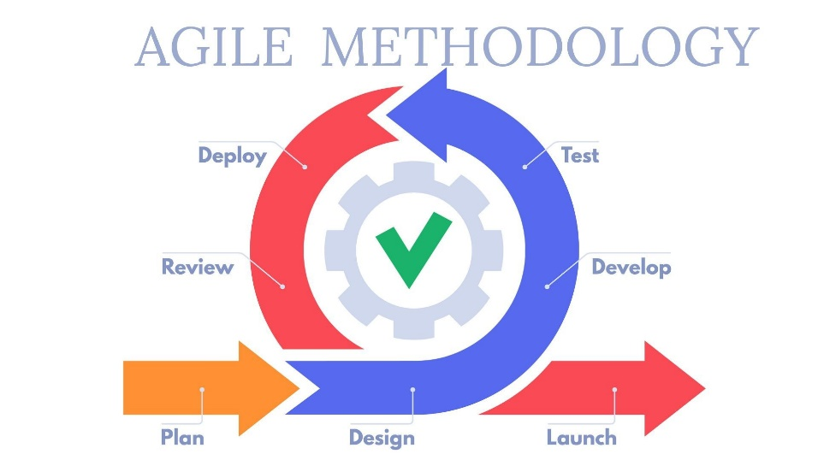

Figure 3: Agile model
(source: https://www.marketing91.com/wp-content/uploads/2020/06/Agile-Methodology.jpg)

Agile Development Method
The following are the phase procedures of Agile Development Method to the researcher project:
Planning Phase
The development process of smart umbrella and android application was executed during the project planning stage. The design phase is a crucial step that collaboration with user and gather feedback to understand researcher need, preferences, and expectations to meet the project requirements for developing system. The objectives of this developing android application are to control and monitor the function of smart umbrella, include the system feature comprised such as finger print authentication, GPS locator and other system functionalities. The Android application was developed using Android studio. while the system of the machine was developed and control using ESP32, where the operation mechanism was executed. The primary goals of this phase are to create a user friendly and efficient system that enhance the user experience and bring users from expectation functionalities into reality.
Design phase
The design phase in the agile development model of smart umbrella and android application project is focus on creating a detailed plan and interface design that meets the requirements and expectation of users for both the umbrella and application. This phase encompassed on flexibility and continuous development, ensuring that the final design is robust, user-friendly, and aligned with the project goals.
Development phase
The development phase of the Smart umbrella and Android application focused on creating a Smart umbrella that is controlled by Android application. The android application is developed using java programing language. The smart umbrella sensors and hardware components are integrated with the android application to enable functionality such as finger print authentication, GPS tracking and user monitoring. Extensive testing is conducted to ensure the application functions properly and meets performance standard.
Testing
The testing phase of a smart umbrella is an integral and iterative part of the development process. In this stage of development, the functionality, durability, physical and software components are needed to be test. Ensuring that any issues are identified and addressed as early as possible.
Deployment phase
The deployment phase is a fifth stage of the development of smart umbrella and android application. Once the smart umbrella and android application are ready. The researcher will deploy the machine to respondent for testing. To determine the user satisfaction for the function, design and feature both machine and application. Include the providing user training and support, monitoring performance and feedback to identify any issues for improvement. This phase ensures a successful and user-friendly launch of the product for it continue success in the market.
Review phase
The review phase for the smart umbrella and android application involves gathering feedback, testing and evaluation, usability assessment, performance analysis, respondent review, documentation, and iterative improvement. This process ensure meets the expected standard, address user need, and provide a seamless and enhance the umbrella experience during deployment testing with respondents.
Launch Phase
The lunch phase of the smart umbrella and android application is a new successful innovative product that can deploy to the market. After all struggle researcher encounter in conducted of meticulous analysis for providing design, data collection, selecting appropriate sensor and testing for ensuring the functionality of both machine and application. The researcher conducted study where his final output is now already complete and ready for deployment to the industry as a modern umbrella in modern age
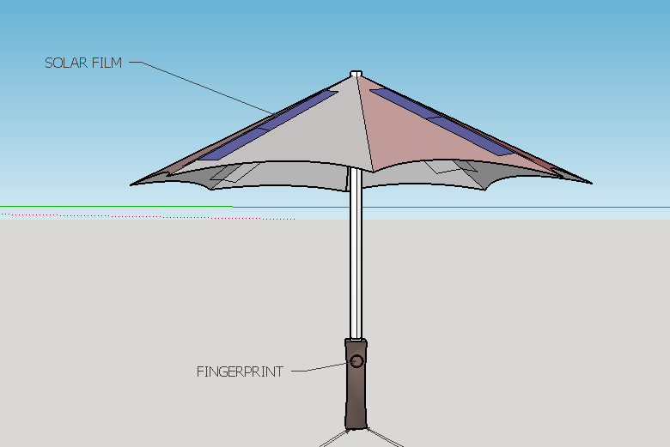
Smart Umbrella design

Figure 3 Smart umbrella design side view
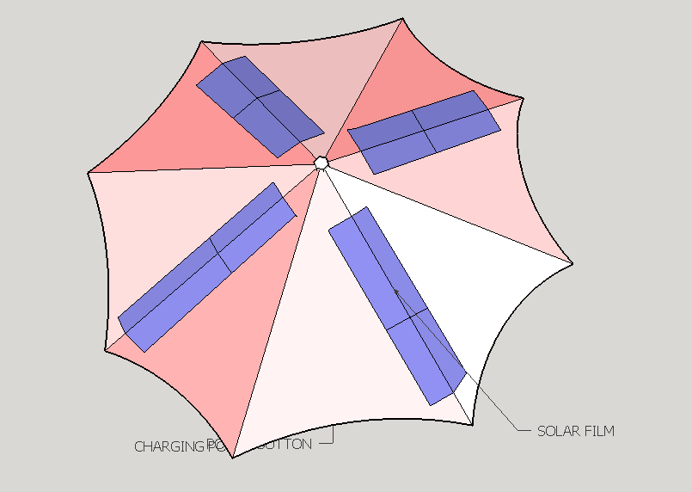

Figure 4 Smart umbrella design top view
Application Design Interface
The Android application serves as a control system for the Smart Umbrella, providing security features for the user. Some aspect of Smart Umbrella features is to insure the user’s registration via app application, and present the the user list in way of active and inactive. Dashboard of Smart Umbrella include user connect to hostpot or wifi Router and setting in part of screen below indicate the GPS location if the user in google map indication. the primary user of this smart umbrella is the owner, the owner needed to register in their own umbrella as an admin, the admin has an authority to monitor and register the intended user.
Upon lunching the application, the first thing that appear to screen is a user welcome greeting and there has three seconds delay to display the second activity, the second design interface is the log in and sign up, the owner required to sign in and input their email and password, while the user is required to sign up for getting data, included their full name, email, user name, If the user successfully completes the registration, the data of user will be automatically saved in user list in the third activity, the user dashboard. The third design interface is the dashboard, where located the function of android application. The battery indicator, user list, registration, setting, connectivity and the location. Once the user completely input the required information, user will be authorized to use and experience the function of advanced technology of the smart umbrella in whenever they want.

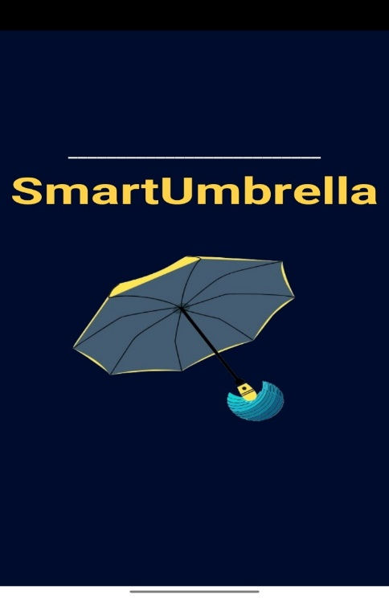

Figure 5: The splash screen of the smart umbrella
In this research, the focus is on introducing the splash screen, which serve as first interface in development of an android application. When user click the starting window, the welcome greeting will display, after 3 seconds delay the log in and sign-up form are displayed, the user required to log in or sign up as a smart umbrella user requirement. The purpose of this registration is to identify the user and provide a list of users who can access the smart umbrella

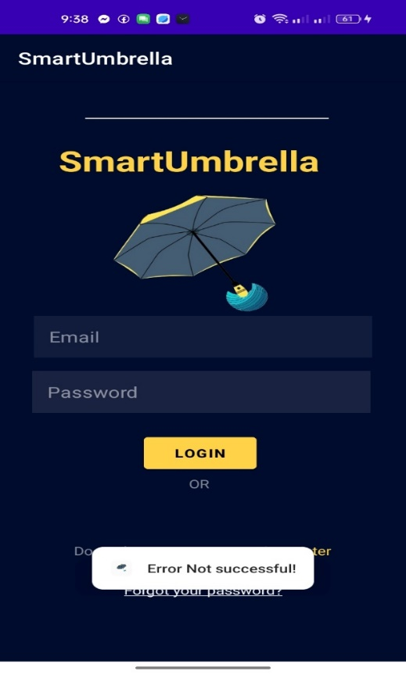
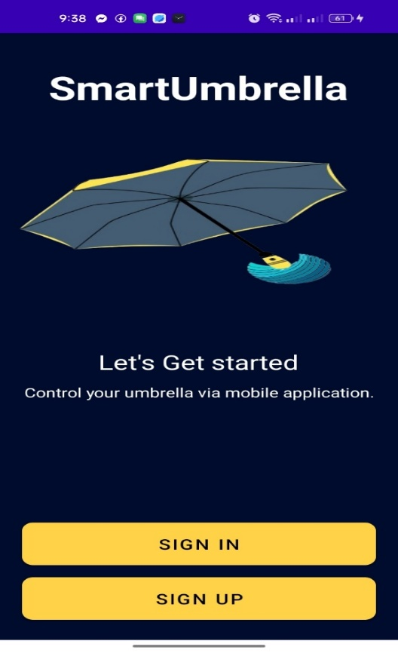

Figure 6 The Log in form and Fingerprint of Smart Umbrella
Figure 6, which serve as the second interface of the Android application. The admin user is registered using the PhpMyAdmin Authentication System database, where the user's Gmail, username and password is stored. Access to the system is granted through the registered account. In addition to the administrator passcode are ‘none’ for username and ‘none’ for password for default login. It is important to note that the login form authentication require an internet connection. Without an internet connection, these features cannot be used. Since it was suggested that the Android app must open in offline mode, allowing users to access the app even without an internet connection.

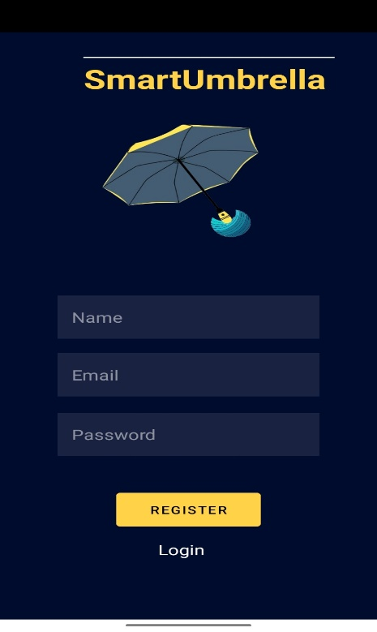
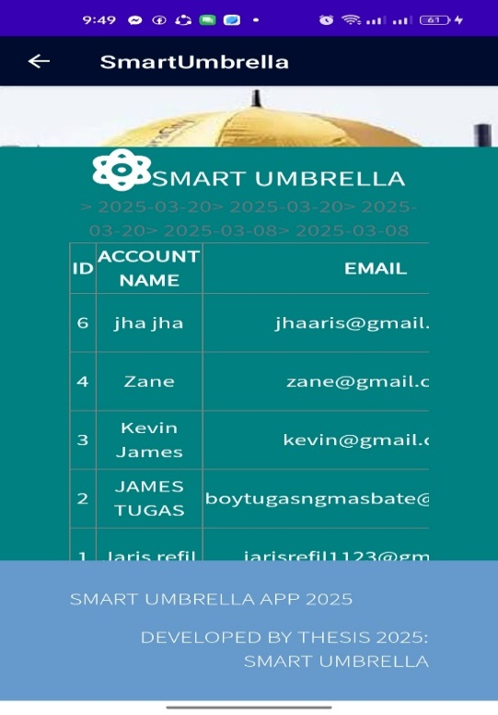
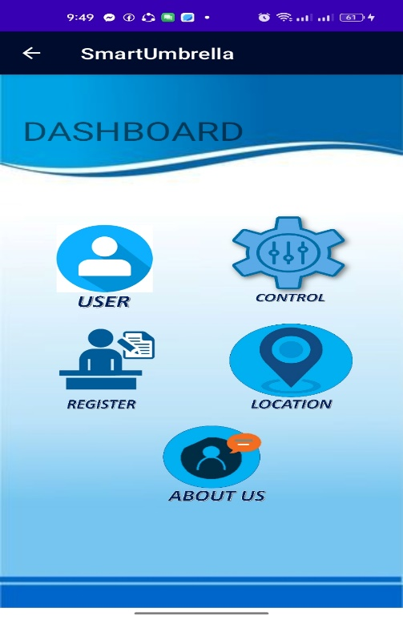

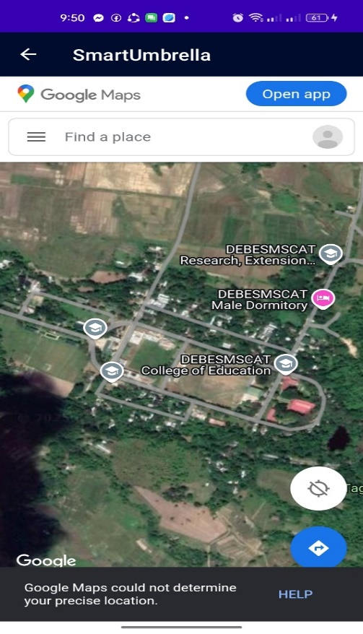
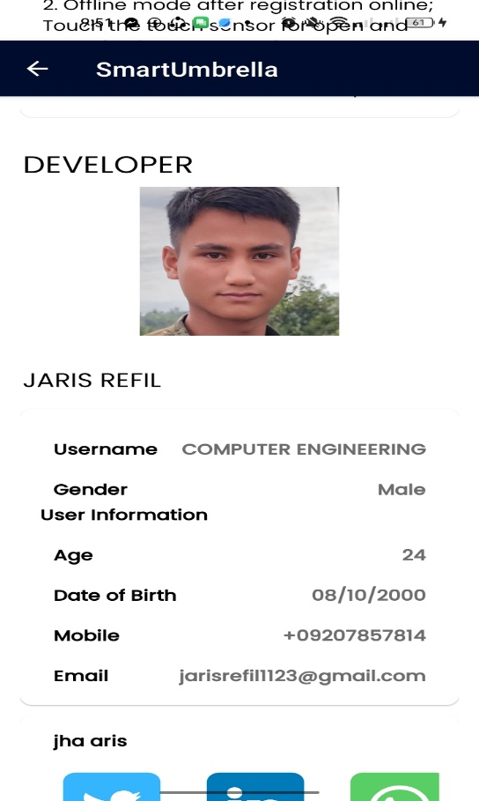
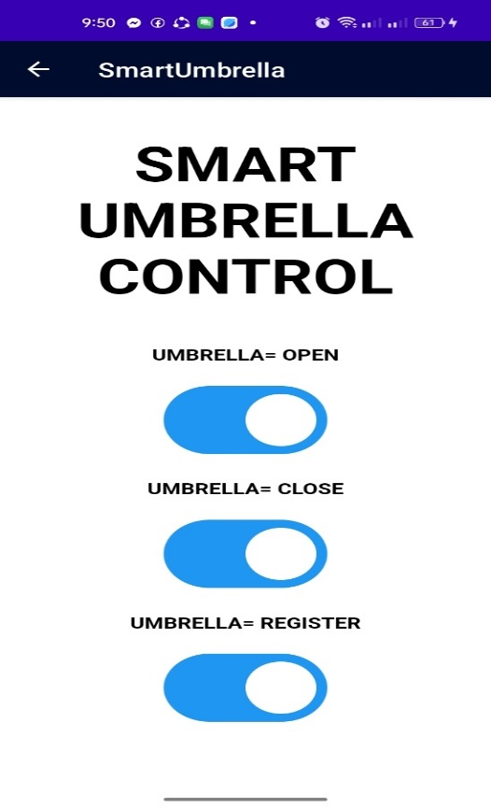

Figure 7: Dashboard interface of Smart Umbrella (source: package com.example. SmartUmbrella)

The dashboard form consists of 5vistinct icons: location, user register, control, map, and about us, each associated with a specific activity form. The control button acts as a command control for the control system also the responsible for the open and close mechanism of umbrella and fingerprint registration, On the other hand, after click specific button splash and proceed to xml display users list in addition of delete and edit by administrator role. includes developer profile allow permission and etc. register for new user platform information include their access in finger print address by register their specific finger print and id.

Integrating firebase console as backend database.
The acquired values of Arduino from the different sensor nodes must be sent and stored to a remote google services firebase server. For this thesis project, the firebase authentication was used as the communication medium to enable a real-time update of the changes done between the two platforms.
Firebase store database Project
Create an account in the firestore app console (https://console.firebase.google.com/project/smart-umbrella-2108e/firestore/databases/) using a email google account. Next, initiate the creation of a new project, assigning it a suitable name and configuring the project mode. Subsequently, generate a collection id name, and table to specific database collection contains field, type, and value. Finally, customize the rules within the rules tab of the Database to facilitate device access.
Arduino IDE
ESP32 nodev3 is a series of low-cost, low-power system on a chip microcontrollers with integrated Wi-Fi and dual-mode Bluetooth use for connection and implemented by libraries in esp32 v2.0 with built-in Bluetooth tools and WIFI integration.

Implementing Firestore Database to Android
Firebase console can be added to any project intended for Android 8.0 (pie) or newer version and have google play services 4.4.2 or newer. Following steps are to be followed next: A project has to be created in android studio coded by android emulator firebase assistance . Enter project name and the 31 locations. Project name under android studio can be anything and can also be different from the Application name given. Login firebase authentication login. The user will be created email google play login in order to connect third party console. Java code coded to webview display inorder to access firestore database.
Adding
In way of setup new user firebase console json authentication sdk provide in android studio in a plan to signing the google services login authentication which provided by java code in android studio.
Firebase Configuration File
Added the extension firebase 21.0.0 google services within Android studio development.
Google Services Gradle Plugin
To access the values from the configuration files in android studio SDK, you'll require the google services Gradle plugin.
Root-level (project-level) Gradle files
In the root-level (project-level) Gradle file (<project>/build. Gradle), add the google services plugin as build scrip dependency.
// Add the dependency for the Google services Gradle plugin
classpath ‘com.google.gms: google-services:4.4.2’
}
Dependency for the Google Services Gradle Plugin (source: https://phpMyadmin.google.com)
Module (App-level) Gradle file
// Add Google services Gradle plugin
id ‘com.google.gms. google-services’
}
Google Services Gradle Plugin (source: https://phpMyadmin.google.com)
Firebase Console Connection
Incorporate the necessary dependencies for the android studio products intended for use in the java code below;

EditText mail;

EditText password;

Button signIn;

ImageButton signInGoogle;

TextView signUp;

TextView forgotPassword;

ProgressBar progressBarLogin;

GoogleSignInClient googleSignInClient;

FirebaseAuth auth = FirebaseAuth.getInstance();

ActivityResultLauncher<Intent> activityResultLauncher;

@SuppressLint("WrongViewCast")

@Override

protected void onCreate(Bundle savedInstanceState) {

super.onCreate(savedInstanceState);

setContentView(R.layout.activity_login_page);

//register

registerActivityForGoogleSignIn();

mail = findViewById(R.id.editTextLoginEmailAddress);

password = findViewById(R.id.editTextLoginPassword);

signIn = findViewById(R.id.buttonLoginPage);

signInGoogle = findViewById(R.id.signInButtonLogin);

signUp = findViewById(R.id.textViewLoginRegister);

forgotPassword = findViewById(R.id.textViewLoginForgotPassword);

progressBarLogin = findViewById(R.id.progressBarLogin);

signIn.setOnClickListener(view -> {

String userEmail = mail.getText().toString();

String userPassword = password.getText().toString();

signInWithFirebase(userEmail, userPassword);

});

signInGoogle.setOnClickListener(view -> signInGoogle());

signUp.setOnClickListener(view -> {

Intent i = new Intent(LoginPageActivity.this, SignUpActivity.class);

startActivity(i);

});

forgotPassword.setOnClickListener(view -> {

Intent intentForgotPassword = new Intent(LoginPageActivity.this, ForgotPassword.class);

startActivity(intentForgotPassword);

});

}

public void signInGoogle(){

GoogleSignInOptions gso = new GoogleSignInOptions.Builder(GoogleSignInOptions.DEFAULT_SIGN_IN)

.requestIdToken("54569090339-8634pkmnm6km1allbajr70brrm2uk5ge.apps.googleusercontent.com")

.requestEmail().build();

googleSignInClient = GoogleSignIn.getClient(this,gso);

signin();

}

public void signin(){

Intent signInIntent = googleSignInClient.getSignInIntent();

activityResultLauncher.launch(signInIntent);

}

public void registerActivityForGoogleSignIn(){

activityResultLauncher = registerForActivityResult(new ActivityResultContracts.StartActivityForResult()

, result -> {

int resultCode = result.getResultCode();

Intent data = result.getData();

if (resultCode == RESULT_OK && data != null) {

Task<GoogleSignInAccount> task = GoogleSignIn.getSignedInAccountFromIntent(data);

firebaseSignInWithGoogle(task);

}

});

}

private void firebaseSignInWithGoogle(Task<GoogleSignInAccount> task){

try {

GoogleSignInAccount account = task.getResult(ApiException.class);

makeText(this, "GO GO Successfully!", Toast.LENGTH_SHORT).show();

Intent i = new Intent(LoginPageActivity.this, DashboardActivity.class);

startActivity(i);

finish();

firebaseGoogleAccount(account);

} catch (ApiException e) {

Toast.makeText(LoginPageActivity.this, Objects.requireNonNull(task.getException()).getMessage(), Toast.LENGTH_SHORT).show();

}

}

private void firebaseGoogleAccount(GoogleSignInAccount account){

AuthCredential authCredential = GoogleAuthProvider.getCredential(account.getIdToken(), null);

auth.signInWithCredential(authCredential)

.addOnCompleteListener(this, task -> {

if (task.isSuccessful()){

Intent i = new Intent(LoginPageActivity.this, SettingActivity.class);

startActivity(i);

finish();

progressBarLogin.setVisibility(View.INVISIBLE);

makeText(LoginPageActivity.this, "Login is successful!", Toast.LENGTH_SHORT).show();

}

});

}

public void signInWithFirebase(String userEmail, String userPassword){

progressBarLogin.setVisibility(View.VISIBLE);

signIn.setClickable(false);

auth.signInWithEmailAndPassword(userEmail, userPassword)

.addOnCompleteListener(this, task -> {

if (task.isSuccessful()){

Intent i = new Intent(LoginPageActivity.this, SettingActivity.class);

startActivity(i);

finish();

progressBarLogin.setVisibility(View.INVISIBLE);

makeText(LoginPageActivity.this, "Login is successful!", Toast.LENGTH_SHORT).show();

}

else {

signIn.setClickable(true);

makeText(LoginPageActivity.this, "Error Not successful!", Toast.LENGTH_SHORT).show();

}

});

}

@Override

protected void onStart() {

super.onStart();

FirebaseUser user = auth.getCurrentUser();

if (user != null){

Intent i = new Intent(LoginPageActivity.this, SettingActivity.class);

startActivity(i);

finish();

}else {

signIn.setClickable(true);

makeText(LoginPageActivity.this, "Error Not successful!", Toast.LENGTH_SHORT).show();

}

} System Design
The system design phase holds significant importance in the, that occurs after the requirements gathering phase and before implementation. During the main focus lies in creating a detailed software system design that aligns with the requirements gathered earlier. It encompasses UI design, initiated through a google search for web images related to IoT Apps, which the developer later finalized in the Android studio. Additionally, the developer devised a process flow for the App's key features, including the display interface for sensor readings and the control interface for threshold values. Moreover, this phase defined the architectural design of the system, encompassing the included components, modules, and database interactions.
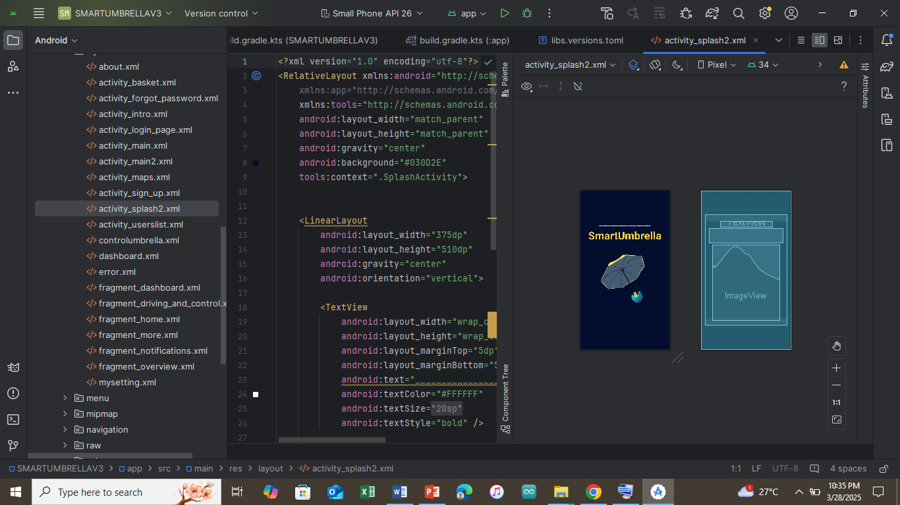

Figure 7 Android Studio App UI Design (source: package com.example. SmartUmbrellav3)

The system design is a crucial component of the Agile Development Method, positioned after the requirements gathering phase and preceding implementation. During this stage, the primary focus is on crafting a comprehensive software system design that aligns with the requirements gathered in the previous phase. Included within this phase is the UI design process, which was initiated through a Google search for web images related to play store. Subsequently, the Developer finalized the design within the Android studio. Additionally, the developer created a process flow for the App's main features, encompassing the display interface and the control interface for those features. Furthermore, this phase encompassed defining the architectural design of the system, involving the components, modules, and database interactions that are included.
System Implementation
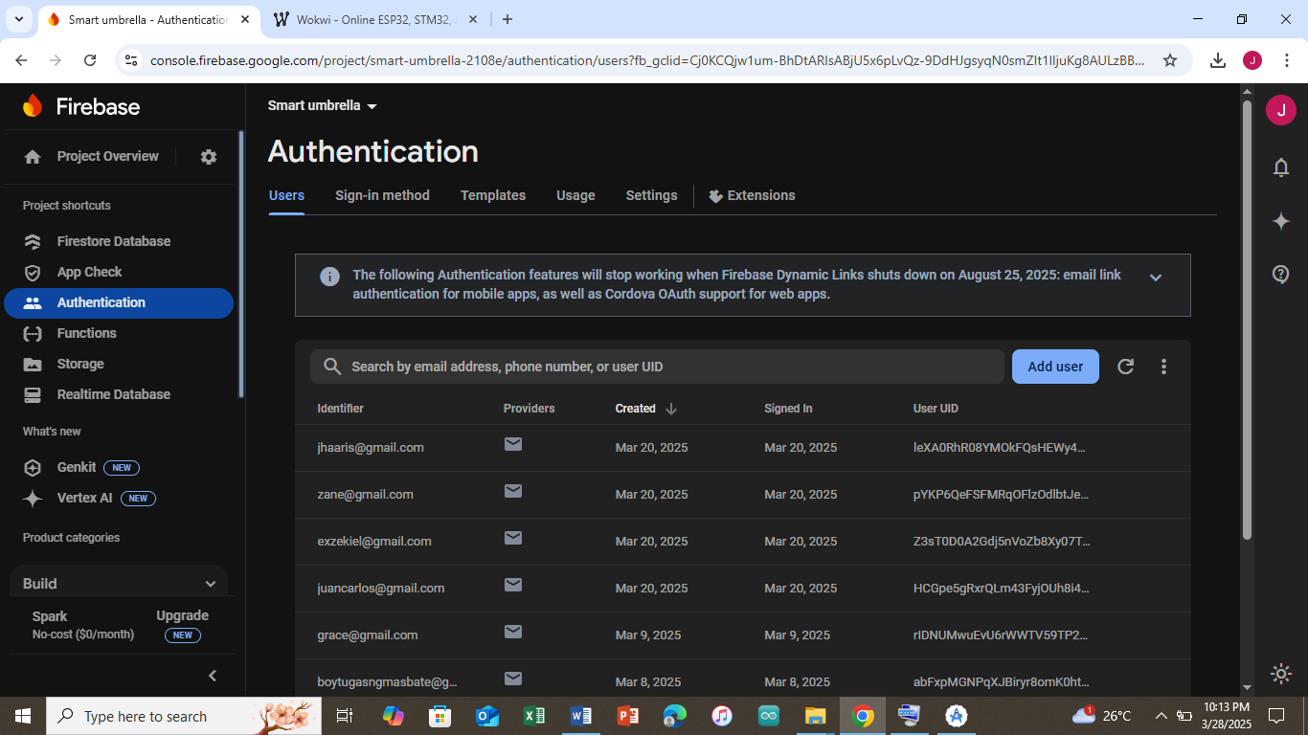
Systems implementation and coding, involves the development of Agile Development Method the approved design and application features based on the required and intended features from earlier phases. Java and xml programming languages were utilized in coding the Android application within Android studio. Developers must ensure thorough and detailed documentation and mapping to effectively implement the design and develop the Application. It is considered a best practice for a developer to verify that the Application functions according to the design specifications time-consuming part of the systems development lifecycle process.

Figure 8 firebase to authentication (sourcehttps://console.firebase.google.com/project/smart-umbrella-2108e/authentication/users)
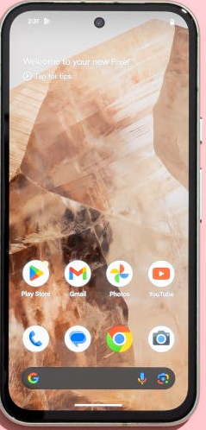
Figure 8. Firebase Authentication aims to make building secure authentication systems easy, while improving the sign-in and onboarding experience for end users. It provides an end-to-end identity solution, supporting email and password accounts, phone auth, and Google, Apple, X, Facebook, GitHub login, and more.
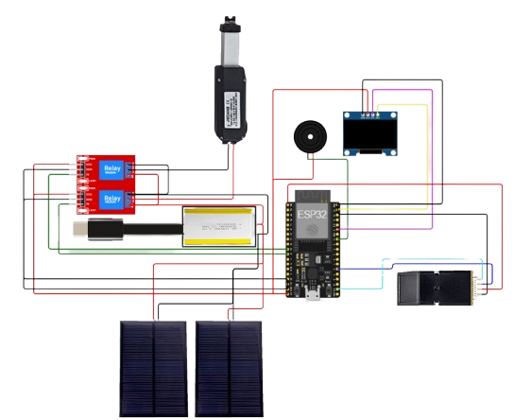
Circuit Diagram

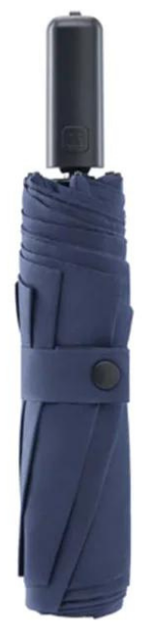

Figure 9 Circuit diagram (source: https://wokwi.org)
In The proposed project idea is visually represented by Figure 9, which displays the circuit diagram of the system.
the 3.3 v solar panel, which harnesses sunlight and converts it into electrical energy. This renewable energy source powers the entire system and charges the battery, ensuring continuous operation even in the absence of direct sunlight.
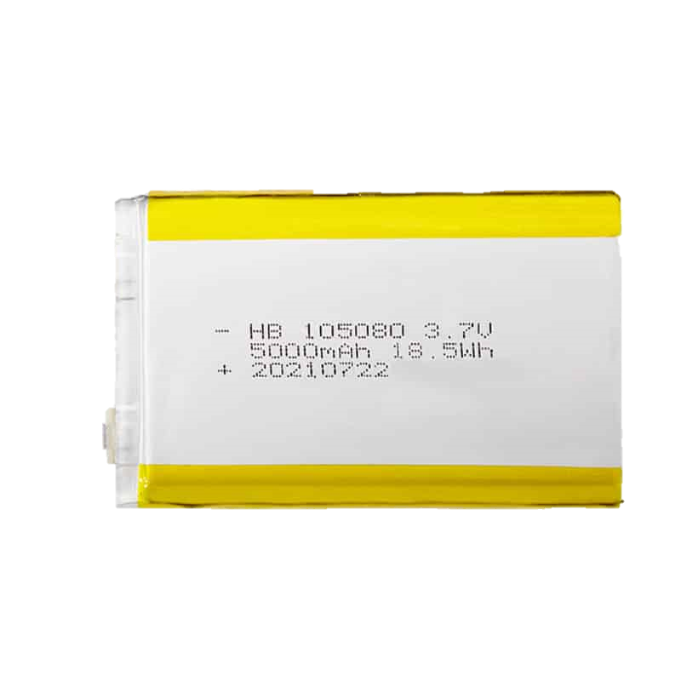
The battery serves as an energy storage unit, storing the harvested solar energy for later use. It provides a stable power supply to the various components, eliminating dependency on external power sources. To control the flow of power, to power the system, an external power telecast with 5000 mAh battery lithium chargeable 3.7v volts is utilized relay is incorporated into the circuit. The switch button invaded in actual board of charging and percentage if battery, allowing or interrupting the power supply as per the system's requirements.
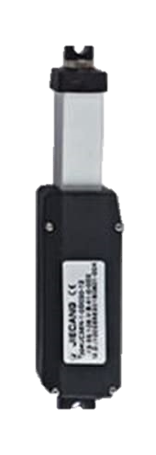
The actuator is a crucial component that enables precise and controlled mechanical movements. It can be programmed to perform specific actions, such as opening or closing of smart umbrella.
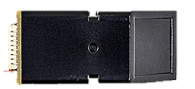
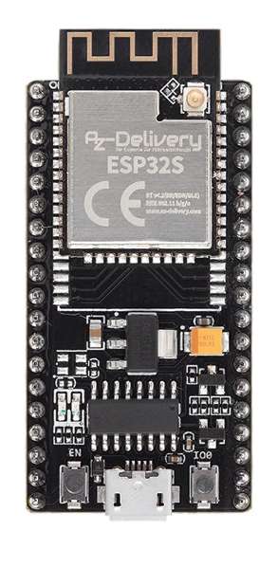
The fingerprint sensor adds an extra layer of security to the system by authenticating users based on their unique fingerprint.

The microcontrollers, ESP32, play a vital role in the system's operation. They serve as the brains of the circuit, executing programmed instructions and controlling the various components. The Arduino Nano offers a robust platform for programming and interfacing with other devices, and also provides a compact and cost-effective alternative. The ESP32, on the other hand, offers additional capabilities such as Wi-Fi and Bluetooth connectivity, expanding the system's potential for remote monitoring and control.
To enhance the system's functionality, a GPS module is integrated, enabling accurate positioning and tracking. This feature can be utilized in applications such as vehicle tracking, asset management, or location-based services.
Furthermore, the circuit includes a charging port and a USB port, allowing convenient power input and data transfer to and from the system.
Research Instrument
The researcher will use a mixed-method approach, combining qualitative and quantitative data collection methods. This approach allows researchers to gain a comprehensive understanding of the umbrella's performance, user satisfaction, and potential areas for improvement. Qualitative method used to gather in-depth insights into users' perceptions, preferences, and experiences with the smart umbrella. Researchers explore users' opinions on the umbrella's design, functionality, ease of use, and overall satisfaction. They can also investigate any challenges or issues encountered while using the umbrella and gather suggestions for enhancements. On the other hand, quantitative methods provide statistical data on various aspects of the smart umbrella's performance. Surveys and questionnaires can be used to collect quantitative data on user demographics, frequency of use, battery life, durability, and other measurable factors. This data can help researchers identify patterns, trends, and correlations among different variables, providing a more objective assessment of the umbrella's effectiveness. By combining qualitative and quantitative data, researchers obtain a comprehensive understanding of the smart umbrella's strengths, weaknesses, and user perceptions. This mixed-method approach allows for a more holistic evaluation, enabling researchers to make informed decisions about potential improvements or modifications to enhance the umbrella's functionality and user experience.
Research Design Considerations
The discussion below is the machine design consideration of the Smart Umbrella:
Safety
Safety considerations for smart umbrellas and android applications involves protecting user data and privacy, ensuring physical safety, includes using high quality materials and construction, implementing coding practices and providing clear instructions and warning to the user, and ensuring user-friendly interfaces to create a secure and reliable product.
functionality
the machine is operated using solar panel, providing a sustainable power source to supply the functionality of umbrella, leading to the integration of features with it comes real-time tracking, providing an extra layer of security through by using of biometric authentication, the android application enhances the functionality, providing umbrella security, safety, and monitoring for the smart umbrella. These features bring sustainability, security and location-based capabilities to the user experience, offering convenience, personalization, and peace of mind.
Operation and Maintenance
Research must focus on user-friendly interfaces, intuitive controls, and clear instructions for assembly, usage, and upkeep. By simplifying operation and maintenance tasks, such as battery charging, software updates, and cleaning, the Smart Umbrella becomes more convenient and hassle-free for User. Moreover, the Android application should offer easy troubleshooting and support features to address any potential issues. This research-driven approach guarantees that the Smart Umbrella and its associated application are not only innovative but also practical and sustainable in the long run.

Components
the following are the selected components to be used in smart umbrella and android application who the responsible to be utilized the function of machine.

Hardware Components
ESP 32
The ESP 32 was built-in Wi-Fi and Bluetooth capabilities are pivotal of its interaction with android applications. This connectivity enables the user to control the various functionalities of the umbrella directly from their smartphone. Also, ESP 32 serves as a database for smart umbrella and its android application. It stores and manages user preferences, open or close the umbrella, monitor its battery level, and track the umbrella location if it gets lost. By utilizing the ESP 32 as a data base, the smart umbrella system can enhance its functionality, provide personalized experiences, and enable seamless communication between the umbrella and android application.
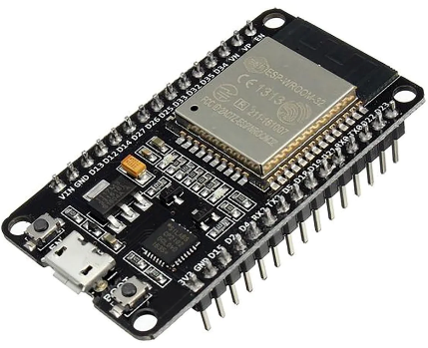

Figure 6: ESP 32 (Source: HTTPs://circuit.rocks/products/esp32-wifi-ble-html)

Optical finger print sensor
the finger print sensor in a smart umbrella used as a user fingerprint authentication of umbrella, close and open mechanism.to ensure that only authorized user can used and enjoy the benefit of the smart umbrella.
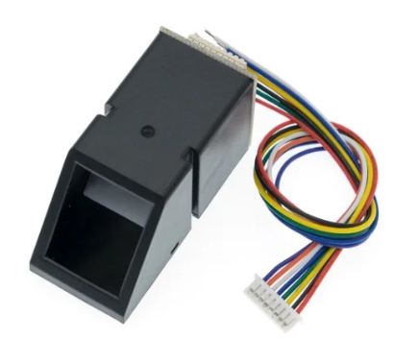

Figure 7: optical finger print sensor
Source: (https://www.sunrobotics.in/shop/)

GPS module
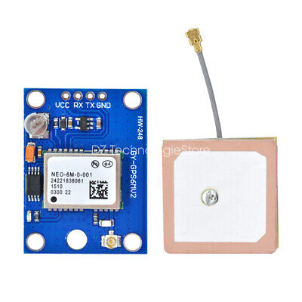
GPS module used for tracking, measuring, and computing the location of the device or system. These features enhance the functionality and the user experience of the smart umbrella, making it a more intelligent and convenient device.

Figure 8: GPS module (Source: https://www.ebay.ph)

actuator
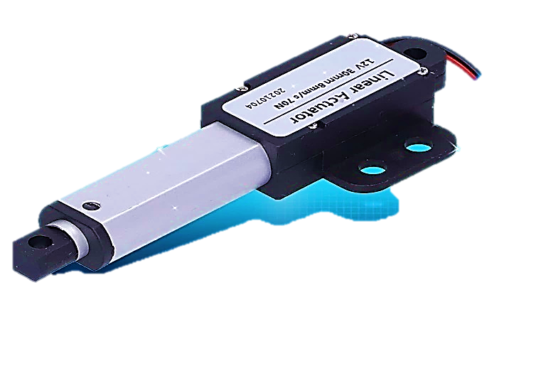
The actuator plays a crucial role in the smart umbrella system by enabling the open and close functionality. This automated process eliminates the need for manual intervention and provides convenience to the user.

Figure 8: actuator (source: https://www.aliexpress.com)

Solar film
The Solar panels was used as sunlight receivers during the day and convert into electrical energy, which is stored in rechargeable battery. This energy storage allows the smart umbrella to operate even when sunlight is not available, such as during cloudy or nighttime conditions.
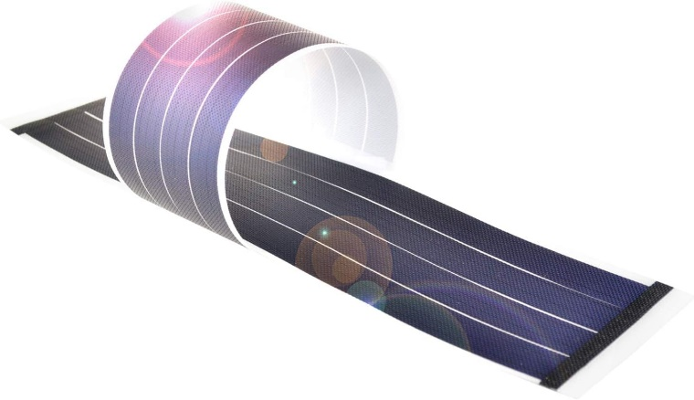

Figure 10: flexible solar film (source: https://www.ubuy.com.ph/product/6XG46T9C)

Battery
The Rechargeable battery is used as storage unit, where the energy got from sunlight and electricity. battery served as power source, emergency backup power and contribute sustainability.

Figure 12: Rechargeable battery
(source: https://www.amazon.com)

USB port
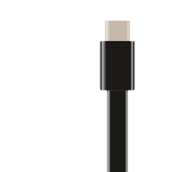
The charging port type c in smart umbrella is an emergency charging portal for additional and backup support to mobile phone for cellphone. Its allowing users to charge their devices in time of emergency situation.

Figure 13: Charging port (source: https://rathyelectronics.com)
Software Components:
Arduino IDE. It is a free integrated development environment that allows the user to write, compile, and upload code to microcontroller boards
Android Studio. Android Studio is the official integrated development environment (IDE) for Google's Android operating system, built on JetBrains' IntelliJ IDEA software and designed specifically for Android development.

Performance test of the machine

The performance test of the machine was conducted to evaluate the open and close mechanism of a smart umbrella. The primary focus of the test was to compute various parameters such as distance forward, average forward speed, average completion time, and power consumption. The test aimed to assess the efficiency and effectiveness of the smart umbrella's mechanism in terms of its average time, speed, and energy usage. The testing will be conducted in 5 trials to ensure the accuracy and reliability of the results. By conducting this performance test, the machine's capabilities and limitations were thoroughly examined, providing valuable insights for future improvements and developments.

Open/ Close Mechanism
The open/close mechanism of a smart umbrella refers to the system responsible for automatically expanding and retracting the umbrella's canopy. This mechanism is designed to facilitate effortless operation, allowing users to easily open and close the umbrella with minimal manual effort. To evaluate the performance of this mechanism, several key functions are computed, including the distance the umbrella travels during opening and closing, the time it takes to complete these actions, and the speed at which the umbrella executes these movements over a given distance, and the battery consumption during operation is also computed to assess the mechanism's energy efficiency. By analyzing these parameters, the overall performance and efficiency of the smart umbrella's open/close mechanism can be accurately evaluated, providing valuable insights into its functionality and user experience. To calculate the distance, average speed, time, and energy consumption for smart umbrella close and open mechanism the following formula can be used.
Distance of Open/ Close Mechanism
The distance of the open / close mechanism refers to the length of travel of the shaft or pole as it moves from a closed to open and opened to close position. The distance of the open/ close mechanism will be calculated using the formula.
Open mechanism
DO=LO [1]
Where;
DO= distance of open mechanism
Lo= length of pole open
Close Mechanism
DC=LC [2]
DC=Distance of close mechanism
LC= Length of pole close
Total Distance for Open/ Close Mechanism
The total distance is referring to the sum of the distance travel by the pole from close to open and open to close. the total distance of close / open mechanism will be calculated using the formula.

TD=DO+DC [3]
Where;
TD= Total Distance
DO= distance of open
DC= Distance of Close
Average Completion Time
The average completion time for the close and open refers to the total time taken by the mechanism complete the operation of open and closing process . the average completion time for close and open mechanism will be calculated using this formula.
T=To+ CT [4]
Where;
T=Completion Time
TO=Time Open
TC= Time close
Average Forward Speed
The average forward speed of the open close mechanism refers to the total average of time and total distance runner travel from open and close position. the forward speed will be calculated using the formula.
Vavg=TD/ CT [5]

Where;
Vavg= average forward speed
TD= Total Distance
CT= Completion Time
Power Consumption

The power consumption refers to the amount of power consumed by the system to complete the open / close process. The power consumption will be calculated using the formula.
P=V x I [6]
Where;
P= power consumption
V= voltage
I= current

Energy Consumption

Energy consumption refers to the total amount of energy used by the machine to perform specific task over the period time. The energy consumption will be calculated using the formula.

EC= PC X OT [7]

EC=Energy consumption (Wh)
PC= power consumption (w)
OT=Operating time (h)
EVALUATION OF MACHINE AND APPLICATION THROUGH QUESTIONNAIRE The total points acquired on the evaluation criteria of the user satisfaction.it was calculated using the following formula.
TP= NE X R
Where:
TP= Total Points
Ne= no. of evaluator
R= Ratings

Chapter IV

RESULTS AND DISCUSSION

This chapter involves the presentation, analysis and interpretation of the data gathered during the conduct of the study.
Description of the machine
The Smart umbrella is composed of the following components: microcontroller, ESP32 Node MCU Wi-Fi module, two 5v solar panel with 1.5-meter stranded wire, a finger print reader, 5v relay, busser, 5v actuator, 9v battery, umbrella, universal connectors, a universal adaptor, and Android application. The actual view of the machine has a dimension of 108 cm height and 200 cm width.
System performance
Before the evaluation of the machine. Preliminary testing was conducted at DEBESMSCAT, the evaluation criteria for the smart umbrella close and open mechanism refers to the assessment of its performance based on four key factors: Distance, speed forward, average completion time, and power consumption. Distance refers to the distance of umbrella canopy move forward when opening and backward when closing, average speed refers to the speed travel of canopy for the distance of umbrella and time complete the close and open execution, average time completion refers to the time it takes for the umbrella close and open execution, lastly power consumption, refers to the amount of energy used by the umbrella motor when executing opening and closing. By evaluating these factors, the efficiency, accuracy, responsiveness and usability of the smart umbrella close and open mechanism can be determined, and the results of this test will help to identify areas of improvement.
the table below presents the performance results obtained from a comprehensive machine testing procedure, to evaluate the device closing and opening capabilities, as well as its overall accuracy. This rigorous testing process aimed to assess the machine's reliability, precision, a d efficiency in executing these fundamental operations, providing valuable insights into its performance and functionality.
OPEN/CLOSE MECHANISM
TRIAL | DISTANCE | SPEED (cm/s) | TIME (s) | ENERGY CONSUMPTION
1 | 72 | 7.03 | 10.23 | 0.0054wh
2 | 72 | 7.15 | 10.06 | 0.0053wh
3 | 72 | 7.17 | 10.4 | 0.0053wh
4 | 72 | 6.96 | 10.33 | 0.0054wh
5 | 72 | 7.03 | 10.23 | 0.0054wh
Table1; data gathered for the performance of smart umbrella close and open mechanism
- Distance; the length of umbrella for open mechanism is 48 cm while the closed mechanism is 24 cm, the distance open will be added to the distance close. The total distance of smart umbrella for it open / close mechanism is 72 cm. the distance of smart umbrella remains constants at 72cm, as it represents the fixed total length from fully open to fully closed.
- Speed; the speed of the smart umbrella open and close execution is calculated by the measuring the distance travel per seconds. To determine the average speed, the total distance will be divided by the average time complete the execution. The speed results from trial 1 to 5 as follow; 7.03 cm/ s, 7.15 cm/s,7.17cm/s, 6.96cm/s, and 7.03 cm/s. these results indicate that the speed remain relatively steady, with only slight variations among trials.
- Time; To determine the average time completion for the close and open execution of the Smart Umbrella, the total time for each trial was calculated by adding the time taken for the open mechanism to the time taken for the close mechanism. The results from the five trials were: trial1;10.23 seconds, trial 2;10.06 seconds, trial 3;10.40 seconds, trial 4;10.33 seconds, and trial 5;10.23 seconds. These times represent the total duration for a complete open and close cycle.
- Energy consumption; the energy consumption of smart umbrella was assessed based on the results of trials conducted. The data is revealed that the umbrella energy consumption is directly to the time it takes to complete an open and close cycle. Trial 1; time complete the execution is 10.23 s it consumed of 35. 7 w/s, trial 2, time 10.06 seconds, energy consumption 36.95 w/s, trial 3; 10.40 s, energy consumption 36.25 w/s, trial 4; time completion 10.33 s, energy consumption,36. 1 w/s, trial 5; time completion, 10.23s, energy consumption 35.7 w/s. The results showed the umbrella consume a minimal amount of power, indicating that the designed is energy – efficient.
Discussion
Based on the results of five (5) trials conducted, the smart umbrella machine undergoes open and close mechanism testing evaluation, the results are presented in table 1 above. The machine performance test involves in four (4) parameter: distance, completion time, average speed, and energy consumption. The researcher focused on the machine performance for its open/ close mechanism based on time, speed, and energy consume. The distance of umbrella for open is 48 cm or 0.48 meter and the distance for close is 24 cm or 0.24 meter with the total distance of 72 cm 0r 0.72 meter. The battery level was 18.5 v or equivalent to 100%.
In trial 1, the 1st user consume of 10. 23 s or 0.00284h the total time for open and close with total speed of 7.04 cm / s, and the energy consume is 0.0054wh
During the second trial, the battery level remained 18. 49 v, representing 99.97% of its battery energy. The second user consume of 10.06s or0.00279h, speed of 7.15 cm/ s with the energy consumption during execution is 0.0053wh. on third trial, the remaining battery level was 18.48 v. the time it took during the third trial was 10.4 s, where equivalent to 0.00289h, the total speed for close and open execution is 7.17 cm/s. the energy consume during third trial was 0.0053wh. for the fourth trial , the battery level remained of 18.4747v or equivalent to 99.86% battery level. The total time consume during execution was 10.33 s or 0.00287, with the speed of 6.96 cm/ s, the energy consumption during fourth trial is 0.0054wh. In the last trial, the battery level remained 18.4693v, equivalent to 99.83%. for the last trial the time user it took for the close and open execution was 10.23 s , with a speed of 7.03 cm/s, and energy consumption is 0.0054wh,and the battery level remained of 18.4639v , equivalent to 99.80%. after the five trial the total energy consume during whole operation was took of 0.0047v or equivalent to 0.2537%.

CHAPTER V
SUMMARY, CONCLUSION AND RECOMMENDATION
SUMMARY
The study was conducted at DR. EMELIO B. ESPINOSA MEMORIAL STATE COLLAGE OF AGRICULTURE AND TECHNOLOGY, cabitan, mandaon, Masbate. this study successfully designed and developed an innovative Smart Umbrella that not only provides convenience but also ensures security and anti-theft protection. The umbrella's cutting-edge technology allows users to secure their umbrella using advanced fingerprint recognition and a dedicated Android application. This dual-security feature ensures that the umbrella can only be opened and closed by its rightful owner, effectively preventing theft and unauthorized use. By integrating these security measures, the Smart Umbrella offers users peace of mind and protection against loss or theft, making it an attractive and reliable accessory for daily use and transforming into smarter, more convenient, and more enjoyable user experience.
CONCLUSION
Based on the results in 5 trial conducted. The researcher concluded that smart umbrella fingerprint recognition system relies on accurate and clear fingerprint images to facilitate successful registration and operation. However, incorrect placement of fingerprint and poor clarity of fingerprint can hinder this process. When a fingerprint is not placed correctly on the biometric, the system may capture a distorted or incomplete image, leading to unsuccessful registration. Similarly, poor clarity of fingerprint, caused by factors such as dirty or oily fingers, can result in a low-quality image that the system cannot recognize. As a result, the smart umbrella's open and closed mechanism may not function. To overcome this issue, users must ensure that their fingerprints are placed correctly on the sensor and that their fingers are clean and dry to facilitate clear and accurate fingerprint recognition.
RECOMMENDATION
To the future developer of Smart Umbrella V2, I recommend integrating two cutting-edge features that will revolutionize the user experience. Firstly, I suggest incorporating real-time weather forecast updates, which will alert users of impending rain or changing weather conditions. This feature will ensure users are always prepared and can plan accordingly. Secondly, I highly recommend integrating an AI-powered voice function translation, enabling the smart umbrella to audibly communicate with users. This feature will allow the umbrella to "speak" and provide voice notifications for various functions, such as "Rain detected, please open me!" or "Umbrella opening" and "Battery fully charged". This innovative feature will not only provide users with a unique and interactive experience but also ensure their safety and convenience.

reference
Rittika Dhar, "The History of the Umbrella: When Was the Umbrella Invented", History Cooperative, January 26, 2023, https://historycooperative.org/when-was-the-umbrella-invented/.
Sun,G. 2018. The urella as a fashion accessory: from protection to style statement. Fashion theory; the journal of dress, body & culture, 22 (2), 193-214.
Anil kumar, ipsheeta Dash, 2023. umbrella market Size & share by product type. User (kids, adult); distribution channel (online, offline)- demand analysis, growth forecasts, statistic report 2021-2027. https://www.researchnester.com/reports/umbrella-market/1919
Smith, M., Johnson. (2023). Evolution of straight and foldable umbrells: development and design trends. Journal of product innovation,20(1), 78-92
Zhou, X., & Hu, X. (2020). Human Factors Engineering Research on Folding Umbrellas Design. In Advances in Ergonomics in Design: Proceedings of the AHFE 2019 International Conference on Ergonomics in Design, July 24-28, 2019, Washington DC, USA 10 (pp. 147-154). Springer International Publishing.
Johnson, E., & chen, D. (2019) strength and weaknesses of traditional umbrella design: journal of materials engineering ,12(3), 45-48.
Liu,s., & Wang, D.(2023). Advancement in umbrella functionality; a comprehensive analysis. Journal of materials engineering and design,17(2),78-92.
O u-Yang H, Shyr T. (2017) protection by umbrellas and wall. Photochemical & photobiological sciences: official journal of the European photochemistry association and the European society for Photobiology.; 16(10): 1537-1545; PMID
Lee, S.,& Chen, D. (2023). Advancements in smart umbrella technology: integration of GPS, USB port, solar panel, and WIFI for enhanced functionality. Journal of technological innovation, 15(2), 78-92.
Pan, J., & Wei, W. 2017 US9820540B2 - Solar umbrella - Google Patents
Hasan.", Nafees, et al. 2021 "Solar Base Smart Beach Umbrella
Carabillo, et al. 2008, US20080092936A1 - Solar powered umbrella - Google Patents
Kumar, Rohit, et al."Digital Umbrella." 2023 3rd International Conference on Advancement in Electronics & Communication Engineering (AECE). IEEE, 2023.
Smith, M. (2023). Security and usability of fingerprint authentication: a comparative analysis. Journal of cybersecurity research, 12(10), 78-92
Chen D. (2021) advancement in fingerprint authentication for user registration; a systematic review. Journal of information security research,8(1), 102-115
Lee, J. (2022). Biometric Authentication: Trends, Challenges, and Future Directions. Journal of Cybersecurity Research, 11(2), 78-92.
Alnabhi, H., Al-naamani, Y., Al-madhehagi, M., & Alhamzi, M. (2020). Enhanced security methods of door locking based fingerprint. Int. J. Innov. Technol. Explor. Eng, 9(3), 1173-1178.
Moon, Jeong-Hun, et al. (2023) "Implementation of Smart Umbrella Stand Based on IoT." Journal of Internet of Things and Convergence 9.1: 57-64.
Han, Y., Lee, C., Kim, Y., Jeon, S., Seo, D., & Jung, I. (2017, January). Smart umbrella for safety directions on Internet of Things. In 2017 IEEE International Conference on Consumer Electronics (ICCE) (pp. 84-85). IEEE.

APPENDICES

Appendix A
DEBESMSCAT Intellectual Property Policy
DR. EMILIO B. ESPINOSA, SR. MEMORIAL STATE COLLEGE OF AGRICULTURE AND TECHNOLOGY
Document No: POL-RDS-03 Eff. Date: 09-24-15

QUALITY MANUAL Revision No: 00

INTELLECTUAL PROPERTY POLICY

I. Definitions
A. Inventions – All inventions, discoveries, computer programs, software, and/or code, methods, uses, products or combinations, whether or not patented or patentable at any time under RA 8293 (Known as Intellectual Property Code of the Philippines) as now existing or hereafter amended or supplemented. B. Creations – Written creations, recorded creations, arts and crafts, mediated creations.
- Written Creations – All literary, dramatic, and musical materials or works and all other APPENDICES reference materials or works including computer programs and software and/or code, published or unpublished, whether or not copyrighted or copyrightable at any time under RA 8293 as now existing or hereafter amended or supplemented.
- Recorded Creations – All sound, visual, audio-visual, and television films (e.g., documentary, animations, etc.), disks, tapes, software and/or codes, recordings or transcription, published or unpublished, whether or not copyright or copyrightable at any time under RA 8293 as now existing or hereafter amended or supplemented.
- Arts and Crafts – Paintings, sculptures, weavings, prints, and other art and crafts whether or not copyrighted or copyrightable at any time under RA 8293 as now existing or hereafter amended or supplemented.
- Mediated Creations – Technology-based academic materials developed for live or delayed communication via video, audio, CD-ROM, computer, internet, or other electronic means now known or hereafter developed, including the software developed to support electronic instructional content for both credit and non-credit courses.

- College Personnel – Part-time and full-time (paid or unpaid) faculty, staff, and student employees of DEBESMSCAT.
- Inventors – College personnel who have developed inventions.
- Creators – College personnel who have developed creations.
- Originator – An inventor and/ or creator.
- Disclosure – A reporting of an invention or creation.

II. College’ Right in Inventions and Creations
- General – Domestic and foreign right to certain inventions and creations developed by the College personnel in performing the duties of their employment by the College or through their substantial use of facilities or funds provided by the College shall be assigned to the College pursuant to a revenue sharing plan for inventor(s) and creator(s). Right of College personnel in invention(s) and creation(s) are provided in a subsequent section of this Statement of Policy.
- College Funds and Facilities – Funds and facilities provided by government, commercial, industrial, or other public or private organizations and administered and controlled by the College shall be considered to be funds and facilities provided by the College.
- Substantial Use – The College recognizes and reaffirms the traditional academic freedom of its faculty to engage in scholarly activity and to publish freely without restriction. In keeping with this philosophy, the College will not construe the payment of salary from unrestricted funds, nor the provision of office or library facilities, as constituting substantial use of college facilities or funds (as this term is used in paragraphs A, D, E and F of this section) except for those situations where the funds were paid specifically to support the development of an invention(s) and/or creation(s).
D. Inventions – The right of the College and its faculty and staff to ownership and disposition of inventions are defined in terms of the categories summarized below:
  - Sponsored Work – Right to inventions which are subject to the terms of a sponsored research or other agreement between the College and a third party are subject to the terms of the applicable agreement, or, in the absence of such terms, the right to the inventions shall be assigned to the College pursuant to a revenue sharing plan for inventor(s).
  - Substantial Use of Funds or Facilities – Right to inventions involving the substantial use of funds or facilities administered by the College, but without any College obligations to third parties in connection with such support, are to be assigned to the College pursuant to a revenue sharing plan for the inventor(s).
  - Without Substantial Use of Funds or Facilities – The College does not assert any right to inventions not involving the substantial use of funds or facilities administered by the College and not a part of the employee’s College duties.
E. Copyrightable Materials: General
The right of the College and its faculty and staff to ownership and disposition of copyrightable materials are defined in terms of the categories summarized below:
  - Sponsored Work – Right to copyrightable materials (including software, but excluding theses and dissertations) which are subject to the terms of a sponsored research or other agreement between the College and a third party are subject to the terms of the applicable agreement, or, in the absence of such terms, the right to the copyrightable materials shall be assigned to the College pursuant to a revenue sharing plan for the creator(s).
  - Substantial Use of Funds or Facilities – Right to copyrightable materials (Including software, but excluding theses and dissertations) involving the substantial use of funds or facilities administered by the College, but without any College obligations to third parties in connection with such support, are to be assigned to the College pursuant to a revenue sharing plan for the creator(s). The right to textbooks ad monographs; other teaching materials, including software developed to support instruction; scholarly and literary publications; and arts and crafts remain with the creator unless such work have been commissioned by the College or have been developed under a sponsored agreement as outlined in paragraph E.1 above.
  - Without Substantial Use of Funds or Facilities – The College does not assert any right to copyrightable materials (including software, but excluding theses and dissertations) prepared without the substantial use of college funds or facilities.
  - Publication of Theses and Dissertations – A student must, as a condition of a degree award, grant royalty-free permission to the College to reproduce and publicly distribute, including by electronic and digital technologies known today or developed in the future, on a non-commercial basis, copies of the thesis or dissertation.
  - Extension and Public Service Agencies – The University retains all right to copyrightable materials developed by staff of its extension and public service agencies as a part of their routine employment duties.

STATEMENT OF POLICY IN PATENTS, COPYRIGHT, AND OTHER INTELLECTUAL PROPERTY
The DEBESMSCAT (referred to as college in this policy) has functioned reasonably well for many years without a comprehensive policy on Patents, Copyright, and Other Intellectual Property. Recent developments in research however, have pointed to the need to develop a more specific policy at this time. These developments include: (1) changes in law that allow colleges and universities to retain ownership of invention and copyrightable materials developed in the course of research and requiring the establishment of procedures for disclosing and developing such inventions and materials; (2) a heightened interest by private/government companies in sponsoring research at universities and colleges, and the need for the College to establish a negotiating position on the ownership of the outcomes of such research; (3) a heightened interest on the part of faculty and staff in commercial development of their credit and non-credit instructional creations and the outcomes of their research; (4) the obligation of the College to support the economic development of its service community by encouraging such commercialization of research outcomes, while maintaining the freedom and integrity of the College’ instructional and research programs.
By explicitly identifying the right of the College, its faculty and stuff, and external research sponsors, this policy, it is hoped, will enhance the research thrust of DEBESMSCAT; provide rewards to faculty and staff; promote the economic welfare of
its service community; and protect the traditions of academic freedom, the open dissemination of research findings, and institutional independence.

General Policy on Patents, Copyright, and other Intellectual Property
The goals of the DEBESMSCAT Policy on Patents, Copyright, and other Intellectual Property is to promote the progress in agricultural researches, teacher education, science and technology, and the arts and the development of the College and faculty through the provisions of an established policy. Patents, copyright, and licensing of intellectual property provide a means for developing and using inventions and creations. This Statement of Policy has been established to ensure that those creative developments in which the College has an equity interest will be used in a manner most likely to benefit the public and at the same time provide compensation to those faculty and staff who invent and create.
To accomplish the above goal, the College holds that it should seek to:
- Assist the faculty and staff in the compensation of their products.
- Make inventions and creations resulting from the efforts of the College personnel available to industry and the public on an affective and non-discriminatory basis; and
- Obtain revenue for faculty and staff who invent and create and for the College for use in furthering its educational and research goals.
F. Copyrightable Materials – Mediated Course Materials
The right of the University and its faculty and staff to ownership and disposition of mediated course materials are shown below.
When an employee develops mediated course materials without substantial use of college funds, facilities, and/ or other employees, ownership of the materials belongs to the creator, who retains the copyright and the right to update, edit, or otherwise revise the mediated course materials and to place time limit upon the use of the materials. Ordinary access to libraries, computers, networks, and course management systems does not constitute substantial use; see E-2 above. Delivery systems and other supporting materials supplies by the other College employees shall remain the property of the College where it is practical to separate them from the course content materials supplies by the creator. The right to control distribution is a right of ownership. However, creators shall not distribute, sell, license or lease the mediated course materials to third parties, or permit the use, advertisement, or promotion of course materials with the College’ name, logo, or other identifier by third parties, in a manner that might constitute a conflict of interest with the College, unless such action has been approved by the College Board of Trustees (BOT). It is understood that faculty members routinely develop and enhance their courses as part of their ordinary employment at the College. However, when a College employee is given specific direction from the College as a special assignment contractual arrangement, and/or within the scope of his/her employment to create or enhance specific mediated course materials, a contract signed by an authorized College official and the employee(s) shall define in writing the right of financial interest that might accrue in the creation, and the parties’ right of approval over licenses, patents, and copyright.

III. College Contracts with Third Parties
DEBESMSCAT has the sole right to make provisions for ownership and disposition of rights to inventions and creations resulting from college contract with third parties.
IV. Statement of DEBESMSCAT IP Policy for Inclusion in Research Proposals and Contract/Agreements
The statement (contained in Appendix B of this manual) regarding the College Policy on Patents, Copyright, and other Intellectual Property shall be included in research proposals and contracts/agreements unless the BOT has approved exceptions to this policy in writing.

V. Statement of Disclosure as Required for College Research Proposals and Contracts/Agreements
The Director for Research is responsible for ensuring that a statement similar to that found in Appendix C of this manual is included on a form submitted with each proposal or contract/agreement. All faculty and staff members who will be participating in the project should sign the proposal or contract/agreement submittal form.

VI. Disclosure of Inventions and Creations
Any invention(s) and creation(s) of potential commercial value, except those excluded by the provisions of this Statement shall be disclosed by the originator(s) in accordance with procedures established in the operating policy of this Statement. The originator(s) shall work closely with the IPR Coordinator of the College to whom the College assigns rights to such inventions and creations in pursuing applications for patents or registering of copyrights as well as in the pursuit of licensing. Likewise, research manuscript (raw data sheets) shall be submitted to the Research and Development Office.

VII. Assistance for Inventions and Creations in Which the College Claims No Rights
The college will provide assistance upon request to college personnel who have developed invention(s) or creation(s) in which the College does not otherwise claim any rights. The assistance provided will be the same as that for inventions and creations in which the College asserts rights. In order to receive such assistance, the originator(s) shall be required to assign rights to such inventions and creations to the College pursuant to a revenue sharing plan for the inventor(s) and/or creator(s).

VIII. Disposing of Inventions and Creations
DEBESMSCAT has the sole right to license, sell, or otherwise dispose of the rights in inventions and creations, which have been assigned to the College.
IX. Assignment of Developments of Potential Commercial Value
The generally policy of the College is to assign the title to invention and creations of potential commercial value that will be handled by the Office of the IPR Coordinator to commercialize the product on behalf of the College. The IPR Office was created to assist faculty and staff of DEBESMSCAT in obtaining patents and copyrights on their inventions and creations and to make available a portion of the income from such inventions or creation for promoting and encouraging further research ad scholarly work. The IPR Office has the right to make assignments with third parties to pursue commercial development or may return all rights to the inventor or creator. However, assignment of an invention or creation to an organization other than the College IPR Office requires the approval of the originator. The College will establish procedures to ensure that originators are kept informed of actions taken to commercialize their inventions and creations, and to encourage originators to advise the IPR Office of potential avenues for commercial development of their inventions or creations.

X. Publication
To fulfil the College’ obligations as a publicly aided educational institution, researchers should serve a public rather that a private purpose and the results should be disseminated on a nondiscriminatory basis. The College encourages studies whose results can be freely published.
The college recognizes that the legitimate propriety concerns of private research sponsors and the effective commercialization of research outcomes may require limited delays in publication. Where appropriate, publications can be deferred for a negotiated period of time in order to protect patent right. Similarly, on those occasions in which the College has accepted a sponsor’s proprietary information as necessary background data for a research project, the sponsors may review proposed publications in order to identify any inadvertent disclosure of those specific data.

XI. Licensing
When the college enters into licensing agreements with third parties, it prefers that nonexclusive royalty-bearing licenses be granted to all qualified licensees. However, an exclusive license may be granted if it is determined that such a grant is required in the public interest to encourage the marketing and eventual public use of the invention or creation.

XII. Publicity
A sponsor shall not use the name of the College or reference to the College in any form of publicity without prior written approval from the College.

XIII. Binding Agreement
This Statement of Policy as amended from time to time shall be part of the conditions of employment of every faculty, staff and student employee of the University. All employees are subject to any changes to this Statement made subsequent to employment.

XIV. Assisting Faculty and Staff

As a part of their normal administrative duties, the department administrators will assist the faculty and staff in realizing the benefits of this policy.

XV. Waiver or Release of College’ Right
The College may elect to waive any claim of ownership under this policy. If the College asserts a claim of ownership, but elects not to seek a patent or copyright or otherwise pursue commercial development for an invention or creation to which it has been assigned right, it will promptly release its right to such invention or creation back to the originator.

XVI. Effective Date and Amendments
This Statement of Policy shall become effective upon after evaluation by the Research and Development Council (RDC) of the College, elevated to the Administrative Council for final review and endorsement to the Board of Trustees of DEBESMSCAT for approval. It may be amended by the Board of Trustees upon the recommendation of any member of the DEBESMSCAT BOT following consultation and approval of the DEBESMSCAT Administrative Council.
OPERATING POLICY ON PATENTS, COPYRIGHT, AND OTHER INTELLECTUAL PROPERTY I. Committee on Patents, Copyright, and other Intellectual Property (PCIP)
- Organization
The PCIP Committee shall consist of the Vice President of Academic Affairs, the director for Research, the Dean of Graduate School, and the IPR Coordinator. The Vice President for Academic Affairs will serve as the chairperson of the PCIP Committee. The Committee may elect such other officers, as it deems necessary. The IPR Coordinator shall act as the Executive Secretary of the Committee and will be responsible for keeping appropriate written records of its proceedings and actions.
- Determination by the PCIP Committee the PCIP Committee shall determine:
  - When the right in and to inventions and creations must be assigned to the College under the provisions of this Statement of Policy pursuant to a revenue sharing plan for inventor(s) and creator(s).
  - The extent, if any, to which the invention or creation was developed by college personnel performing the duties of their employment of through their substantial use of facilities or funds provided by the College.
  - Whether in the interest of fairness to the originator(s), or for any other reason, the College should waive or release any or all of its right in a particular invention or creation.
  - Whether more than one individual is entitled to right in any invention or creation.
  - The manner in which the right in inventions and creations of college personnel as a group shall be divided among the individual’s constitution the group, provided, however, that if such individuals shall have reached agreement among themselves, such agreement shall be controlling.
  - The appropriate assignment of inventions or creations.
- Sponsored Project in cases of inventions or creations developed in the course of sponsored project, determinations of the Committee shall be subject to the provisions of any contacts to which the College is a party.
- Assignment of Inventions and Creations by the College
The PCIP Committee has the responsibility to make assignments of the College right in inventions and creations in accordance with Section VIII of the General Policy.
II. Procedure
- Disclosure of Inventions and Creations
The College personnel shall promptly disclose all right in inventions and creations, which may be assigned to the College under the provisions of this Statement of Policy, in writing to the Committee. The disclosure shall be through the department head, director, dean, or the Research and Development Services Director or through an appropriate procedure prescribed by the R and D Office. If more than one individual participated in the discovery or development, the disclosure shall be signed by all participants. The disclosure shall be in accordance with the guideline provided by the PCIP Committee. The participants shall furnish additional information as needed and shall assist the PCIP Committee in the execution of the necessary documents from time to time to facilitate the commercialization of inventions and creations. College personnel who question whether rights in a specific invention(s) and/or creation(s) must be assigned to the College under this Statement of Policy shall request in writing a determination by the PCIP Committee. The Request shall be made through the Director of Research and Development Services.
- Action by the Committee
The committee shall promptly consider all disclosure of inventions and creations and request for a determination of right and shall make the determination required within a reasonable time. The College personnel involved in the disclosure shall be entitled to appear before the Committee and present evidence with respect to the disclosure. The Committee’s determination shall be made in writing and shall contain a statement of its finding and ground for decision.
- Review of Committee Action
Actions of the PCIP Committee may be appealed in writing through the SUC President to the Board of Trustees.

ROLE OF RESEARCH AND DEVELOPMENT SERVICES IN THE OPERATIONALIZATION OF THE DEBESMSCAT IP

POLICY
The DEBESMSCAT Research and Development Services is one of the arms of DEBESMSCAT created to provide services along
DEBESMSCAT on research. One of its purposes is to promote and manage research and technology commercialization within the College, including assistance to faculty and staff in the procurement of patents and registering of copyright and the licensing thereof to support research at the various institute in the Undergraduate Programs and in the Graduate School.
Relative to this function, the following specific policies are adopted for its operation:
- The research and Development Services shall create an IP Office that (a) shall function as coordinator of patenting, licensing, and/or copyright of inventions and creations developed by the College employees and students; (b) shall coordinate with PCIP
on matters pertaining to policies of the College on IPR. IP Office shall function through an IP Coordinator that shall be designated by the Office of the President following recommendation from the Director of Research and Development Services Office that shall commence duty upon approval of the BOT.
- When a potential patent or copyright is development by the College employee (hereafter referred to as originator), it is the policy of the R&D Office to offer the originator an agreement, whereby if a patent or copyright is obtained in the name of the originator it will be assigned to the College, with any resulting income to be shared with the originator.
- If the potential patent or copyright was developed using College time or facilities, the College will share with the originator at the originator’s option, either 15% of any gross income resulting, or 50% of any net income resulting after all costs of obtaining, defending, licensing, and administering the patent or copyright have been paid. At the Originator’s request, the office will:
  - Deduct a designated portion of the originator’s share of income from a patent or copyright and pay such amount directly to the College, for purposes designated by the originator, or
  - Designate a smaller share of income to be paid to the originator than that specified in the second paragraph above.
- In determining distributions for research support, it shall be the policy of the Office tb b o allocate to each institute, 50% of the office available net income resulting from patents, copyrights, discoveries, and developments originating from that institute.
- The remaining 50% of the College’ net income may be allocated to the administration of other research incentives and rewards grant for the purpose of encouraging and developing multi-campus research initiatives.
- It shall be the policy of the R&D Office through its IPR Unit to maintain its operating expenses at the lowest feasible level consistent with prudent management of its resources and effective service to faculty and staff of the College.
- For the privilege of acting as the patent, copyright and licensing agent for DEBESMSCAT, the R&D Unit shall provide the following services.
  - Investigate diligently the patentability, suitability for copyright registration, and commercial potential of all inventions and creations so assigned.
  - Obtain patents or register copyright on those outcomes deemed patentable or suitable for copyright, and of potential commercial value, or, alternatively, to arrange for direct commercial development without patent protection or copyright registration where this appears to be a more attractive option.
Pursue an active licensing program for its inventions and creations. The normal mechanism for transfer of technology is a non-exclusive license. Where required for the effective development of inventions and creations to the point of commercial availability, however, DEBESMSCAT will negotiate exclusive license for a limited term.

Appendix B
Statement of Contract with the Fabricators

This agreement is covered by the Intellectual Property Policy (contained in lll. College Contracts with Third Parties) in which DEBESMSCAT (referred to as a college in the policy) has the sole right to make provision for ownership and disposition of rights to inventions and creation resulting from college with third parties. It is understood that the fabricator’s interest to the invention/creation will be accordance with the existing policy.

ROLLY MAGBANUA JARIS D REFIL
owner of welding and repair shop student researcher

Appendix C.
Statement of Disclosure

It is understood that all discoveries, inventions and other intellectual property made or received in performance of work on this subject will be the property of DEBESMSCAT or in accordance with the contract terms for this project; College policies and procedures are design to assure that the interest of the inventor/researchers, the college and the sponsors are taken into considerations; and the principal investigator(s) will furnish prompt and full disclosure of inventions/research findings made during performance of this project to the Research and Development Services Office.

JARIS D REFIL
Student Researcher

Source: DEBESMSCAT Research and Development Services Quality Management System Manual (202
Appendix D

GANTT CHART

 | Aug 2022 |  | Sept 2022 |  |  | Oct 2022 |  |  | Nov 2022 |  |  |  |  | DEC 2022
 | 1-15 | 16-31 | 1-13 | 14 | 15-30 | 1-12 | 13 | 12-31 | 1-4 | 5 | 6-14 | 15 | 16-30 |  | 1-7 | 8
T1
T2
T3
T4
T5
T6
T7
T8

Deployment
Thesis Defense
Development
Planning

Appendix E. Task, Duration, Activities
Task | Activities | Duration
T1 | - Meeting with the CpE Practice and design Instructor  - Partner Selection  - Selection of Adviser  - Meet the Adviser | August 1-15, 2022
T2 | - Partner Brainstorming  - Discussion about project thesis in CpE Practice and design  - Gathering data and ideas in the internet  - Surfing possible title in the internet | August 16-30, 2022
T3 | - Preparing for the data that are needed for the outlined defense  - Group work for the introduction and objectives | September1-13, 2022
T3 | - First Title thesis Defense | September 14, 2022
T4 | - Partner Brainstorming  - Consultation to Thesis Adviser  - Encoding the manuscript chapter I  - Preparing for the data that are needed for the outlined defense  - Group work for the introduction and objectives | September 15 up to October 12, 2022
T4 | - Second Title thesis Defense | October 13, 2022
T5 | - Major Revision in title thesis of CpE Practice and design I  - Formulating ideas about design methods and procedures  - Researching related literature in internet | October 12 up to November 4,  2022
 | - Thesis Defense | November 5, 2022
T6 | - Minor Revision in title thesis of CpE Practice and design I  - Designing the User interface and machine design of the project  - Finalized the flow of the project | November 4-14, 2022
T6 | - Thesis Defense | November 15, 2022
T7 | - Start coding  - Redesigning of the User application interface and machine design of the project  - Creating miniature of the project into scrap | November 16 up to December 7, 2022
T7 | - Pre-Oral-defense
T8 | - Redesigning of the User application interface and machine design of the project  - Pre-consultation to thesis adviser  - Revising research paper  - Improving machine design  - Machine testing  - Data gathering  - Presentation of Machine and its android application
T8 | defense

Appendix F. evaluation Questionnaire
Smart umbrella
Evaluation Form
Name of Evaluators (Optional): Date:
Course / 0year: _______________________________ age: ______________
- Instruction: On a scale of 1 to 5, rate the following question by filling the box below that corresponds to your answer
Rating Criteria
LEGEND
1 = very Dissatisfied
2 = Dissatisfied
3 = Neutral
4 = Satisfied
5 = Very Satisfied

CRITERIA | Ratings
User Interface
Smart umbrella Android Application
A. How much do you like the items used such as the buttons and icons in the App?
B. How satisfied are you with the ease of using application for the first time?
C. how satisfied are you with the overall design and layout of the application?
TOTAL
Functionality Testing
Smart umbrella Android Application
A. How you satisfied the app's ability to retrieve and display its functionality to the machine?
B. How do you rate the Application performance during use?
C. In your experience, how satisfied are you with using the components or functions of the App?
TOTAL
Smart umbrella Machine
A. How well did the Smart umbrella machine meet your specific needs and requirements?
B. How experience with the usability of the different functions on the Smart umbrella machine?
C. How likely you appreciate the usable of solar panel after using?
TOTAL
Usability
Smart umbrella Android Application
A. How would you rate your overall satisfaction with the application?
B. How much do you appreciate the App's ease of use?
C. How satisfied are you with the App's performance in relation to both its functional capabilities and machine learning capabilities?
TOTAL
Smart umbrella Machine
A. Please rate the effectiveness and reliability of the safety features incorporated in the Smart umbrella?
B. How satisfied are you with overall usability of the open/ close mechanism of the machine using fingerprint sensor?
C. how much do you appreciate the security of the Smart umbrella?
TOTAL

      - What specific suggestions can you proposed to enhance the functionalities of the Android application designed for the Smart Umbrella Machine?

      - Can you share your thoughts on how the smart umbrella can be improve to better meet your needs?

Comments/ Suggestions:

Signature of Evaluators

Appendix G. machine performance sheet
OPEN/CLOSE MECHANISM
TRIAL | DISTANCE (cm) | SPEED (cm/s) | TIME (s) | ENERGY CONSUMPTION
1
2
3
4
5

Appendix G. Components Consumption
COMPONENTS | VOLTAGE (v) | CUURENT(A) | POWER CONSUMPTION(W)
ESP 32 | 5V | 0.16 | 0.8
ACTUATOR | 5V | O.3 | 1.5
FINGERPRINT SENSOR | 3.3 V | 0.12 | 0.396
BUZZER | 5V | 0.01 | 0.05
CHARGING PORT | 5V | 2 | 10
GPS | 5V | 0.02 | 1
STEP UP DC MOTOR | 5V | 5 | 25

Table 1: Data gathered for the performance of the machine.
OPEN/CLOSE MECHANISM
TRIAL | DISTANCE (cm) | SPEED (cm/s) | TIME (s) | ENERGY CONSUMPTION
1 | 72 cm | 7.03cm/ s | 10.23 s | 0.0054wh
2 | 72 cm | 7.15cm/ s | 10.06 s | 0.0053wh
3 | 72 cm | 7.17 cm/s | 10.4 s | 0.0053wh
4 | 72 cm | 6.96cm/s | 10.33 s | 0.0054wh
5 | 72 cm | 7.03 cm/s | 10.23 s | 0.0054wh

Solution;
Trial 1
Open / Close mechanism Average of completion time
T=OT + CT
Time=?
Open Time= 5.14s
Close Time= 5.09s
TT=5.14S+5.09S
TT= 10.23S
Total Distance of Open/ Close Mechanism
TD=OD+OC
TD= 48+24
TD= 72 Cm
Average speed of close / open mechanism
Average speed for open mechanism;
S-Open= D-Open/T-Open
S-open=48cm/5.14 s
S-Open= 9.34 cm/s
Average speed for Close mechanism
S-close=D-close/T-close
S-close=24cm/5.09s
S-close=4.72cm/s
Total Average Speed of Close / open Mechanism
TS=SO+SC/2
TS= 9.72+4.72/2
TS= 7.03 cm/s
Power consumption
P=V x I
P- actuator = 5v x0.3 A
P- actuator= 1.5w
p-fingerprint= 3.3v x 0.12 A
p-fingerprint= 0.396
Total power consumption
P= 1.5 +0.396
P=1.896w
Energy consumption
EC= PC x OT
EC= 1.896 w x 0.00284 h
EC = 0.0054wh
TRIAL 2
Open / Close mechanism Average of completion time
T=OT + CT
TT=5.37s+5.23s
TT= 10.6 s
Total Distance of Open/ Close Mechanism
TD=OD+OC
TD= 48+24
TD= 72 Cm
Average speed of close / open mechanism
Average speed for open mechanism;
S-Open= D-Open/T-Open
S-open=48cm/5.37 s
S-Open= 8.93 cm/s
Average speed for Close mechanism
S-close=D-close/T-close
S-close=24cm/5.23s
S-close=4.59cm/s
Total Average Speed of Close / open Mechanism
TS=SO+SC/2
TS= 8.93+4.59/2
TS= 7.15 cm/s
Power consumption
P=V x I
P- actuator = 5v x0.3 A
P- actuator= 1.5w
p-fingerprint= 3.3v x 0.12 A
p-fingerprint= 0.396
Total power consumption
P= 1.5 +0.396
P=1.896 w
Energy consumption
EC= PC x OT
EC= 1.896 w x 0.00279h
EC = 0.0053
TRIAL 3
Open / Close mechanism Average of completion time
T=OT + CT
TT=5.25S+5.15S
TT= 10.4 s
Average speed of close / open mechanism
Average speed for open mechanism;
S-Open= D-Open/T-Open
S-open=48cm/5.25 s
S-Open= 9.14 cm/s
Average speed for Close mechanism
S-close=D-close/T-close
S-close=24cm/5.15s
S-close=4.66 cm/s
Total Average Speed of Close / open Mechanism
TS=SO+SC
TS= 9.14+4.66
TS= 13.8 cm/ s
Power consumption
P=V x I
P -actuator = 5v x 0.3 A
P= 1.5 w
p-fingerprint= 3.3v x 0.12 A
p= 0.396
Total power consumption
p=1.5 w +0.369 w
P=1.896 w
Energy consumption
EC= PC x OT
EC= 1.896w x 0.00279h
EC = 0.0053wh

TRIAL 4
Open / Close mechanism Average of completion time
T=OT + CT
Time=?
Open Time= 5.16s
Close Time= 5.17s
TT=5.16S+5.17S
TT= 10.33S
Average speed of close / open mechanism
Average speed for open mechanism;
S-Open= D-Open/T-Open
S-open=48cm/5.16 s
S-Open= 9.30 cm/s
Average speed for Close mechanism
S-close=D-close/T-close
S-close=24cm/5.17s
S-close=4.64cm/s
Total Average Speed of Close / open Mechanism
TS=SO+SC
TS= 9.30+4.64
TS= 13.94cm/ s
Power consumption
P=V x I
P -actuator = 5v x 0.3 A
P= 1.5 w
p-fingerprint= 3.3v x 0.12 A
p= 0.396
Total power consumption
p=1.5 w +0.369 w
P=1.896 w
Energy consumption
EC= PC x OT
EC= 1.896 w x 0.00287
EC = 0.0054 wh
TRIAL 5
Open / Close mechanism Average of completion time
T=OT + CT
TT=5.07S+5.16S
TT= 10.23S
Average speed of close / open mechanism
Average speed for open mechanism;
S-Open= D-Open/T-Open
S-open=48cm/5.07 s
S-Open= 9.47cm/s
Average speed for Close mechanism
S-close=D-close/T-close
S-close=24cm/5.16s
S-close=4.65cm/s
Total Average Speed of Close / open Mechanism
TS=SO+SC
TS= 9.47+4.65
TS= 14.12 cm/ s
Power consumption
P=V x I
P -actuator = 5v x 0.3 A
P= 1.5 w
p-fingerprint= 3.3v x 0.12 A
p= 0.396
Total power consumption
p=1.5 w +0.369 w
P=1.896 w
Energy consumption
EC= PC x OT
EC= 1.896w x 0.00284 h
EC = 0.0054wh

APPENDIX FLOWCHART.

Appendix F
FLOWCHART SYMBOLS AND THEIR MEANING

TERMINATOR
Terminator symbols used to designate the beginning and the end of the program or a point of interpretation.
DATA I/O
Input/output represent the instruction to an input or output device.
PROCESS
Processing symbols used to represent a group of program instruction that perform a processing function of the program such as to perform arithmetic operation, or to compare, sort etc.
DICISION/ CONDITIONAL
Decision symbols denotes a point in the program where more than one path can be taken
STORED DATA
This is general data stored object used in the process flow.
LINES
Denotes the direction of logic flow in the program

Flowchart 1: smart umbrella Registration
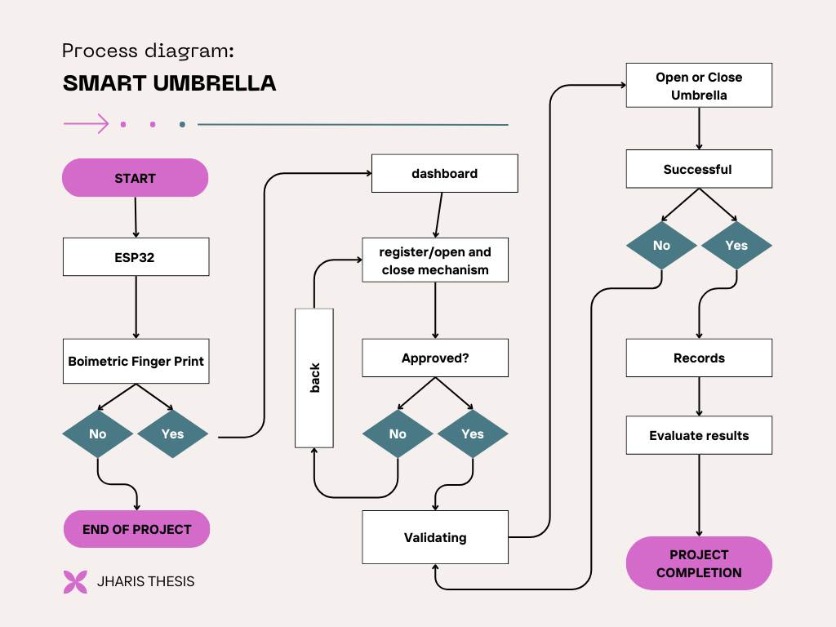
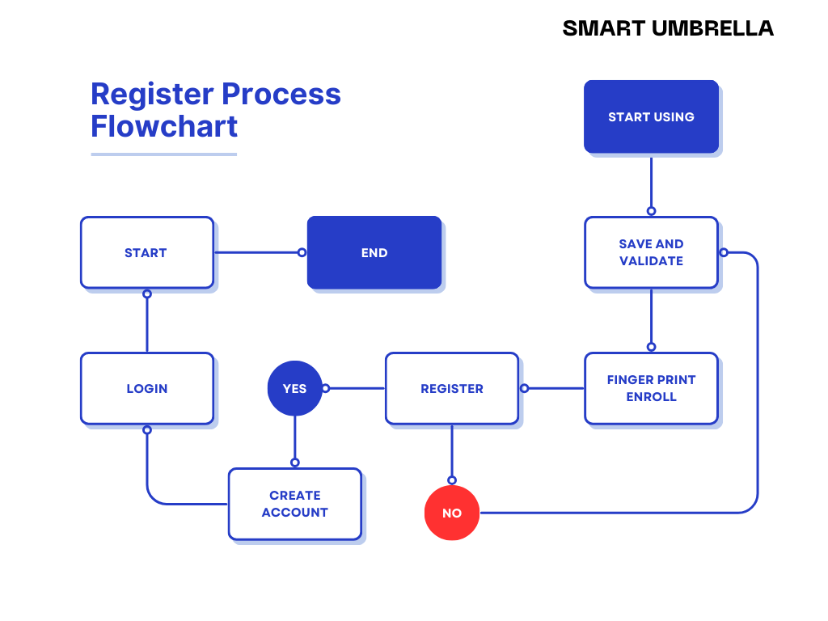
Flowchart 2: smart umbrella machine
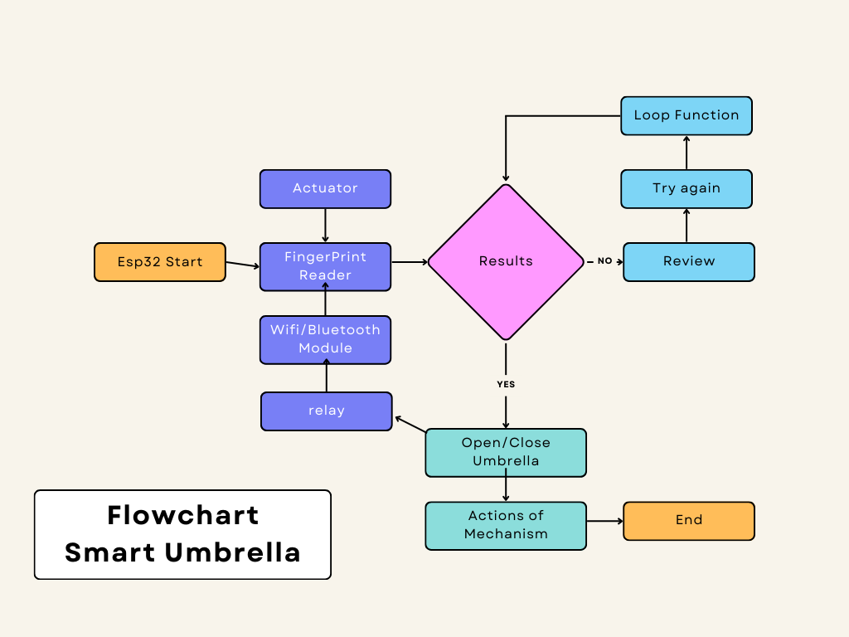

Flowchart 3: smart umbrella and android application process diagram

Appendix G. Algorithm
Start of algorithm
Smart umbrella Application
      - Click the icon of the Application
      - Register User info
      - Log in Using Registered user info
      - Dash board display
a. connectivity
b. User Account info
c. Register Finger Print of User
d. Open and Close mechanism
e.. Location
f. battery percentage
g. Smart Stroller Icon includes developer profile
Smart umbrella Machine
            - Turn on the power button of the machine
            - Click the biometric of the machine
- Place your registered finger to biometric to open
- Place your registered finger to biometric to close
- Click the power button to shutdown

Appendix T. User’s Manual
To establish a connection between the Android application features and the Smart umbrella, a straightforward setup process is required. This setup involves a few key steps aimed at enabling smooth communication and data exchange between these two components.
For Application;
              - Download the Application of Smart umbrella.
              - Set up the Registration form, to log in.
              - Touch the sign in text to proceed to log in form
              - Input user personal information
              - Registered finger print
1.To check if user already registered.
  - go to dashboard
  - click user icon
- if already registered
  - click connect icon
  - turn on wi fi
  - connect your device to the machine
- to view user registered list.
  - Click user icon
  - Search user name
- registered icon has selection
- edit user info
- delete user
- to locate umbrella
  - go to dashboard
  - click location icon
- to view battery percentage, click battery icon

Appendix
Components datasheet
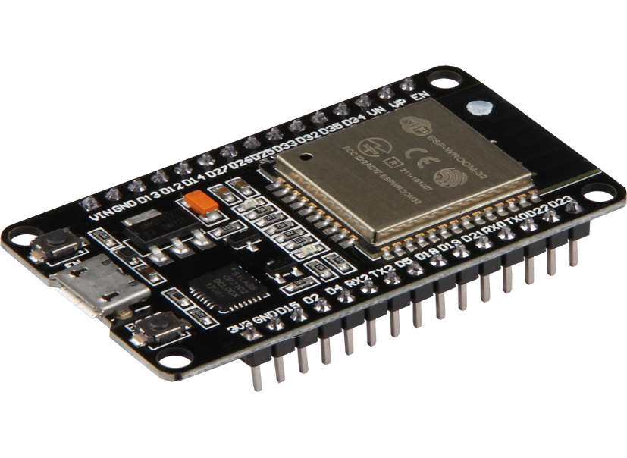
Overview
ESP32

ESP32 is a powerful, generic Wi-Fi + Bluetooth® + Bluetooth LE MCU module that targets a wide variety of applications, ranging from low-power sensor networks to the most demanding tasks, such as voice encoding, music streaming and MP3 decoding. The integration of Bluetooth, Bluetooth LE and Wi-Fi ensures that a wide range of applications can be targeted, and that the module is all-around: using Wi-Fi allows a large physical range and direct connection to the Internet through a Wi-Fi router, while using Bluetooth allows the user to conveniently connect to the phone or broadcast low energy beacons for its detection. The sleep current of the ESP32 chip is less than 5 µA, making it suitable for battery powered and wearable electronics applications. The module supports a data rate of up to 150 Mbps, and 20 dBm output power at the antenna to ensure the widest physical range. As such the module does offer industry-leading specifications and the best performance for electronic integration, range, power consumption, and connectivity
Esp 32 Description
ESP 32 | DESCRIPTION
Core | 2
Architecture | 32 bits
Clock | Tensilica Xtensa LX106 160-240MHz
WiFi | IEEE802.11 b/g/n
Bluetooth | Yes - classic & BLE
RAM | 520KB
Flash | External QSPI - 16MB
GPIO | 22
DAC | 2
ADC | 18
Interfaces | SPI-I2C-UART-I2S-CAN

ESP32 features and specifications
- Processors – The ESP32 uses a Tensilica Xtensa 32-bit LX6 microprocessor. This typically relies on a dual core architecture, with the exception of one module, the ESP32-S0WD, which uses a single-core system. The clock frequency reaches up to 240MHz and it performs up to 600 DMIPS (Dhrystone millions of instructions per second). Moreover, its low power consumption allows for analog to digital conversions as well as computation and level thresholds, even while the chip is in deep sleep mode.
- Wireless connectivity – The ESP32 enables connectivity to integrated Wi-Fi through the 802.11 b/g/n/e/i/. Moreover, Bluetooth connectivity is made possible with the v4.2 BR/EDR, and the series also features Bluetooth low energy (BLE).
- Memory – Internal memory for the ESP32 is as follows. ROM: 448 KB (for booting/core functions), SRAM: 520 KB (for data/instructions), RTC fast SRAM: 8 KB (for data storage/main CPU during boot from sleep mode), RTC slow SRAM: 8 KB (for co-processor access during sleep mode), and eFuse: 1 KiBit (256 bits used for the system (MAC address and chip configuration) and 768 bits reserved for customer applications). Moreover, some of the ESP32 chips, including the ESP32-D2WD and ESP32-PICO-D4, have internally connected flash. See the respective internal flash memory for each chip in the ESP32 Chips section.
- External flash and SRAM – ESP32 supports up to four 16 MB external QSPI flashes and SRAMs with hardware encryption based on AES to protect developers’ programs and data. It accesses the external QSPI flash and SRAM through high-speed caches.
- Security – The ESP32 supports all IEEE 802.11 standard security features, including WFA, WPA/WPA2 and WAPI. Moreover, ESP32 has a secure boot and flash encryption.

B. P/NS: GPSMOD1315
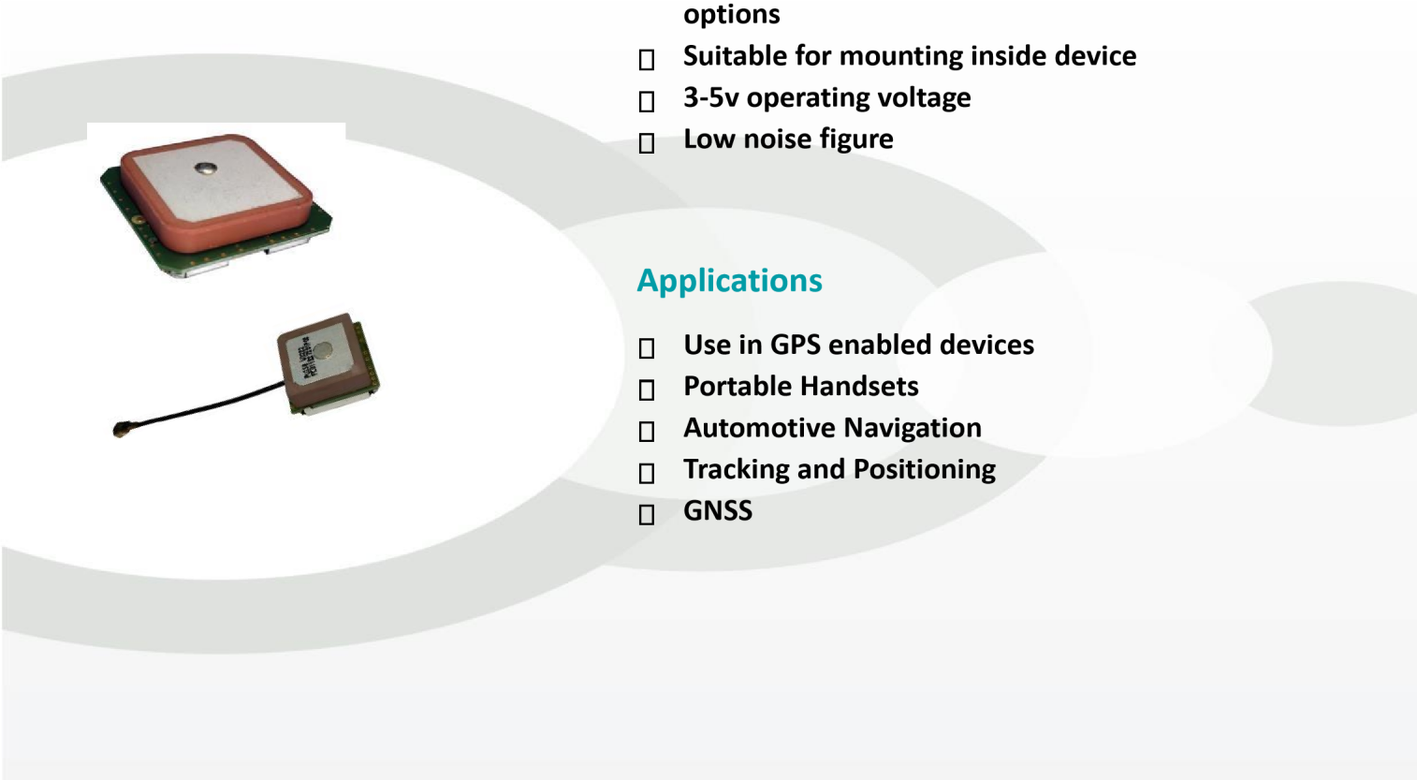
Features

Small form factor

Includes low noise amplifier (LNA) 16 and 33dB
- 3-5v operating voltage
- Low noise figure
Application
- Use in GPS enable devices
- Portable Handsets
- Automotive Navigation
- Tracking and Positioning
- GNSS
Confidential and Proprietary – Pulse Electronics – All Rights reserved – 2015
This document contains confidential and proprietary information of Pulse Electronics, Inc. (Pulse) and is protected by copyright, trade secret and other state and federal laws. Its receipt or possession does not convey any rights to reproduce, disclose its content, or to manufacture, use or sell anything it may describe. Reproduction, disclosure or use without specific written authorizati0on of Pulse is strictly forbidden. Information subject to change without noti0ce.
For More Information
Pulse Worldwide Headquarters Larsen Brand Antennas Europe Headquarters  Pulse (Suzhou) Wireless Products Co, Inc.
12220 World Trade 3611 NE 112th Ave Pulse GmbH & Do, 99 Huo Ju Road (#29 Bldg., 4th Performance warranty of products
Drive | KG Phase offered in this data
San Diego, CA Vancouver, WA  92128 -98682 | Zeppel instrasse 15 Suzhou New District sheet limited to the  Parameters specified another brand.
USA | Herzenberg, Science & Tech Industrial Park product names mentioned herein Germany may be trademarks.
 | Jiangsu Province, Suzhou 215009 or registered trademarks of their PR China respective owners.
Tel:1- 858-674-8100 Tel: 1-360-944-7551 | Tel: 49 7032 7806 Tel: 86 512 6807 9998 ©Copyright, 2015. Pulse  0 Electronics, Inc. All rights
Fax: 1-858-674-8262 Fax: 1-360-944-7556 | Fax: 49 7032 7806 Fax: 86 512 6809 8023 Reserved.135

 |  | GPSMOD1315 |  | GPSMOD1333 |  | GPSMOD2515 |  | GPSMOD2533
ELECTRICAL SPECIFICATION
FREQUENCY |  | 1575.42mhZ |  | 1575.42mhZ |  | 1575.42mhZ |  | 1575.42mhZ
NOMINAL IMPEDANCE  (Ω) |  | 50 |  | 50 |  | 50 |  | 50
VSWR |  | 1.5:1 |  | 1.5:1 |  | 1.5:1 |  | 1.5:1
GAIN RADIATING ELEMENT |  | -1dBic +/- 1 dB |  | -1dBic +/- 1 dB |  | 3.4dBic +/- 1 dB |  | 3.4dBic +/- 1 dB
GAIN LNA |  | 16 dB +/- 1 dB |  | 33 dB +/- 2 dB |  | 16 dB +/- 1 dB |  | 33 dB +/- 2 dB
LNA NOISE FIGURE |  | < 2.4 dB |  | < 2.4 dB |  | < 2.6 dB |  | < 3.4 dB
POLARIZATION |  | RCHP |  | RCHP |  | RCHP |  | RCHP
OPERATING VOLTAGE |  | 3.3-5 Vdc +/- 0.5  V |  | 3.3-5 Vdc +/- 0.5  V |  | 3.3-5 Vdc +/-  0.5 V |  | 3.3-5 Vdc +/-  0.5 V
CURRENT  COMSUMPTION |  | < 6A mA |  | < 10A mA |  | < 6A mA |  | < 10A mA
ENVIRONMENTAL SPECIFICATIONS
OPERATION -40 to | +85°C -40 t | o | +85°C -40 to |  | +85°C -40 to |  | +85°C TEMPERATURE
MECHANICAL SPECIFICATIONS
WEIGHT |  | 4.8g |  | 4.8g |  | 13.5g |  | 13.5g
DIMENSIONS |  | 13 mm x 13 mm |  | 13 mm x 13 mm |  | 25 mm x 25 mm |  | 25 mm x 25 mm
CABLE LENGTH |  | 32mm |  | 32mm |  | N/A |  | N/A
MOUNTING |  | DOUBLE SIDED  ADHESIVE TAPE  PROVIDED |  | DOUBLE SIDED  ADHESIVE TAPE  PROVIDED |  | DOUBLE SIDED  ADHESIVE  TAPE  PROVIDED |  | DOUBLE SIDED  ADHESIVE  TAPE  PROVIDED
CABLE TYPE |  | 0.81mmCOAXIAL |  | 0.81mmCOAXIAL |  | N/A |  | N/A
CONNECTOR |  | U. FL & IPEX  COMPLIANT |  | U. FL & IPEX  COMPLIANT |  | Solder pads for coaxial cable |  | Solder pads for coaxial cable

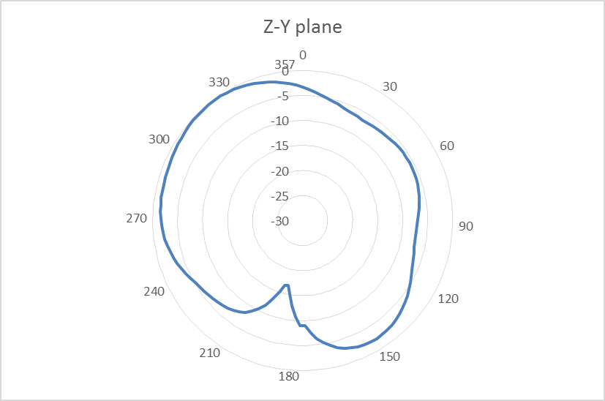



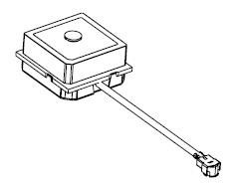

PATTERN DATA

–

GPSMOD1315

X

Y

Z

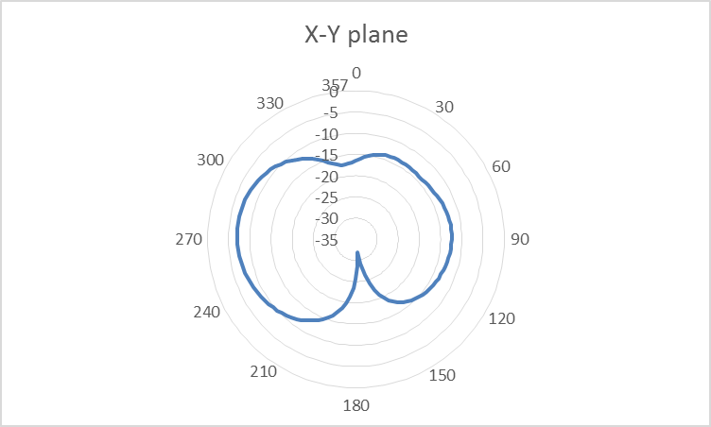
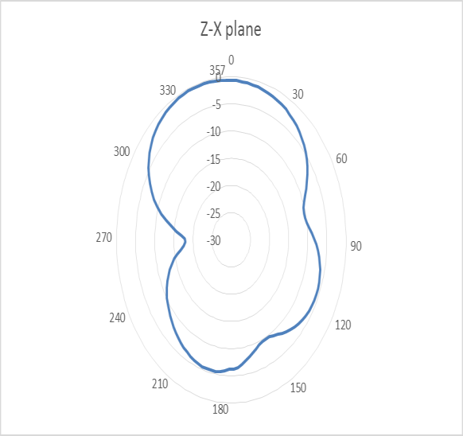

 | Out of Ban d Rejection
698MHz |  |  | 75dB
960MHz |  |  | 80dB
1710MHz |  |  | 70dB
2170MHz |  |  | 60dB
2400MHz |  |  | 60dB
2700MHz |  |  | 55dB
698MHz | 90dB
960MHz | 80dB
1710MHz | 70dB
2170MHz | 65dB
2400MHz | 65dB
2700MHz | 75dB

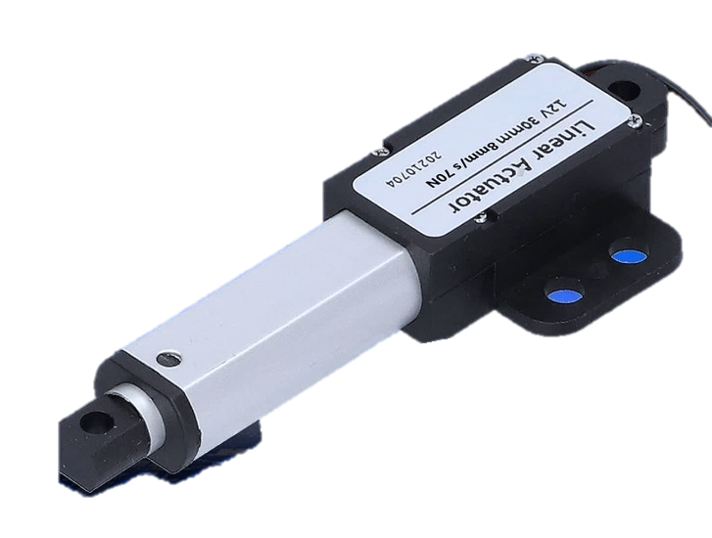
Micro Linear Actuator, Mini Electric Linear Actuator

Application:
These miniature linear actuators are small, light, quiet and very durable. Suitable for applications that require limited space and minimal force. Mainly used for small doors, windows, furniture, medical & health equipment, agricultural machinery, vehicles, ships, drones, aircraft models, car models, ship models, robotics, remote controls (RC) and so on. It can open, close, push, pull, rise and drop these devices.
Feature:
High-quality products and high-quality services
High strength metallic zinc alloy housing protects motor and gear
Metal gearbox, high strength wear-resistant gear
Stainless steel telescopic tube and aluminum alloy outer tube, good corrosion resistant
Strong thrust, up to 188N / 19 Kgs / 42 lbs
Multiple speed options, from 5 mm/second to 150 mm/second
Multiple stroke options, from 10 mm to 100 mm
Advanced waterproof and dustproof technology
Low power consumption and low noise
Built-in two limit switches (not adjustable), linear actuator will automatically stop when stroke rod reaches the limit position.
Automatically lock after stopping, and no power supply is required.
Maintenance-free
Specifications:
Optional working voltage: 6V DC, 12V DC or 24V DC
Optional stroke: 10mm
Installation length: 54.5mm + Stroke
Optional speed: 5mm±1mm/s, 7mm±2mm/s, 9.5mm±2mm/s, 15mm±3mm/s, 30mm±5mm/s, 50mm±10mm/s, 150mm±20mm/s
The above is the speed at no load, and the actual working speed will gradually slow down as the load increases.
Max Load capacity: 188N / 19 Kgs / 42 lbs at 5mm/second
Linear actuator can get maximum load capacity when it operates in the vertical direction, and the pulling force is less than pushing force.
No-load current: 0.02~0.04A at 12V, or 0.01~0.02A at 24V, or 0.04~0.08A at 6V
Full load current: 0.2~0.3A at 12V, or 0.1~0.15A at 24V, or 0.4~0.6A at 6V
Outer tube diameter: 12*16mm
Telescopic tube diameter: 6*9mm
Mounting holes diameter: 4mm
Housing Material: Zinc Alloy
Stroke Rod Material: Stainless Steel
Outer Tube Material: Aluminum Alloy
Gear Material: Steel Alloy
Motor Type: Brushed DC Motor
Duty Cycle: 10%
Service life: approx. 50,000 cycles
Plug Standard: Ordinary Two-core Wire
Power cord length: 345 mm
Certifications: CE
Environment temperature: -26℃ to 85℃
Operating Noise: about 45dB~55dB (Linear actuators with different parameters will have different noise levels.)
IP rating: IP54, not suitable for outdoor use
Operation:
When linear actuator is connected to DC power supply, the stroke rod will extend outward; after switching the power in the reverse direction, the stroke rod will retract inward.
The direction of movement of the stroke rod can be changed by switching the polarity of DC power supply
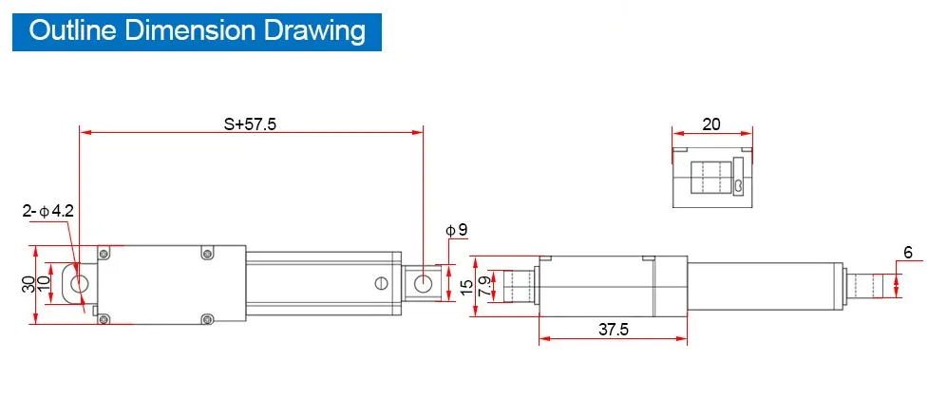
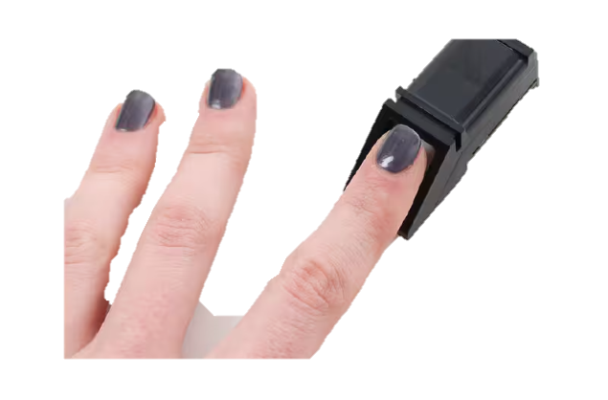
Adafruit fingerprint sensor
- Supply voltage: 3.6 - 6.0VDC
- Operating current: 120mA max
- Peak current: 150mA max
- Fingerprint imaging time: <1.0 seconds
- Window area: 14mm x 18mm
- Signature file: 256 bytes
- Template file: 512 bytes
- Storage capacity: 162 templates
- Safety ratings (1-5 low to high safety)
- False Acceptance Rate: <0.001% (Security level 3)
- False Reject Rate: <1.0% (Security level 3)
- Interface: TTL Serial
- Baud rate: 9600, 19200, 28800, 38400, 57600 (default is 57600)
- Working temperature rating: -20C to +50C
- Working humidity: 40%-85% RH
- Full Dimensions: 56 x 20 x 21.5mm
- Exposed Dimensions (when placed in box): 21mm x 21mm x 21mm triangular
- Weight: 20 grams
Mini solar Panel
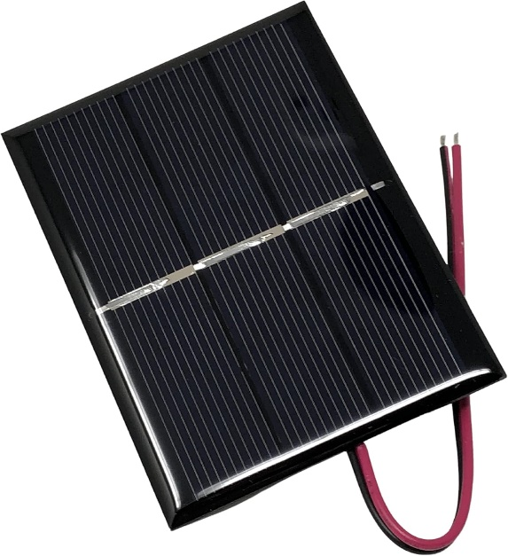
Construct a small, portable solar panel that will charge two AA rechargeable batteries in a day or two. Use the batteries to make any battery-powered device solar powered. Or use the panel to directly power small DC electronics.
The panel consists of eight 1"x3" solar cells wired in series with a blocking diode mounted on a board and protected by clear plastic. In this configuration the panel provides about 250 milliamps at 4 volts, which will charge two batteries in a day or two, depending on the weather and the batteries' capacity. Other solar cell configurations are possible to provide more or less power to, for instance, directly charge a 3.6 volt cell phone battery, or to provide a faster charge to AA batteries.
There are a number of off-the shelf small solar panels available on the web, but building one yourself gives you the flexibility to configure it to provide exactly the voltage and amperage your project needs. And it could be cheaper
5v RELAY
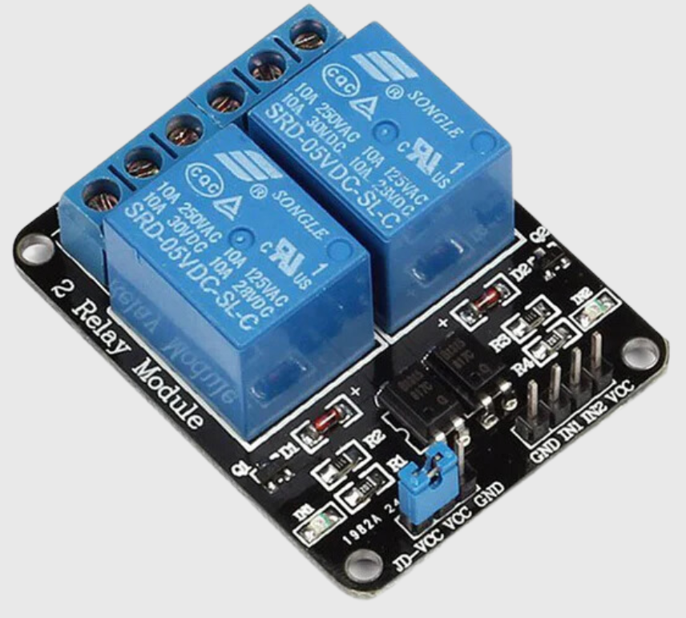
A relay is a device which is used to provide connection between two or more points or devices in response to the input signal applied. In other words, relays provide isolation between the controller and devices, which may operate on either AC or DC. However, they receive signals from a microcontroller which works on DC hence requiring a relay to bridge the gap. Relay is extremely useful when you need to control a large amount of current or voltage with small electrical signal.
There are 5 parts in every relay:
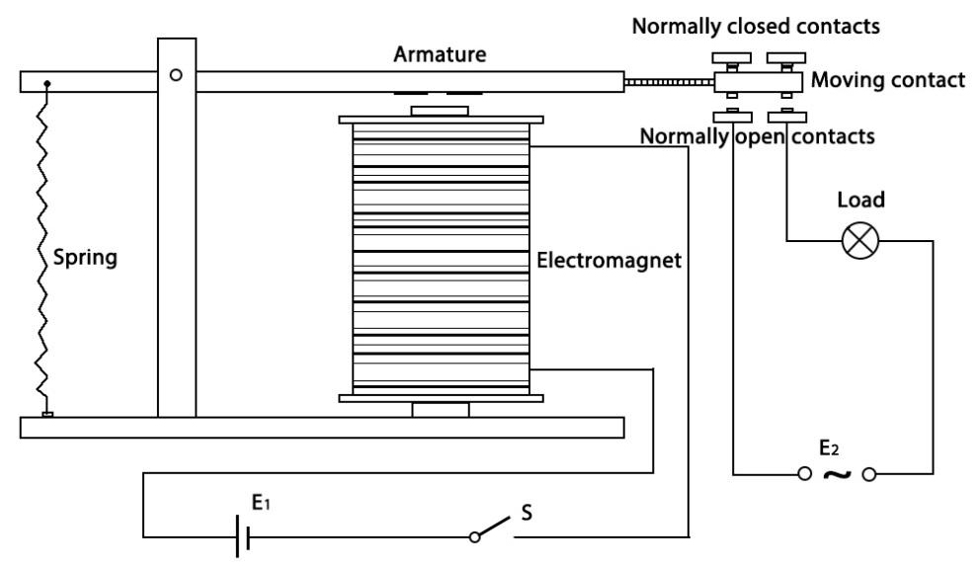
Electromagnet - It consists of an iron core wounded by coil of wires. When electricity is passed through, it becomes magnetic. Therefore, it is called electromagnet.
Armature - The movable magnetic strip is known as armature. When current flows through them, the coil gets energized thus producing a magnetic field which is used to make or break the normally open (N/O) or normally close (N/C) points. And the armature can be moved with direct current (DC) as well as alternating current (AC).
Spring - When no currents flow through the coil on the electromagnet, the spring pulls the armature away so the circuit cannot be completed.
Set of electrical contacts - There are two contact points:
- Normally open - connected when the relay is activated, and disconnected when it is inactive.
- Normally closed - not connected when the relay is activated, and connected when it is inactive.
Molded frame - This is typically made of plastic and provides structural support and protection for the relay.

